

**F8 - ONLINE LEARNING**

**Software Requirement Specification**

– Hanoi, August 2022 –

**Record of changeS**

| **Date** | **A* M, D** | **In charge** | **Change Description** |
| --- | --- | --- | --- |
| 27/May | A | AnhNDHHE163634 | Thêm mô tả chức năng User Login Screen (II.1.a) |
| 27/May | A | TriLMHE163206 | Thêm mô tả chức năng User Register Screen (II.1.b) |
| 27/May | A | TriLMHE163206 | Thêm mô tả chức năng Course Detail Screen (II.1.c) |
| 27/May | A | DungDTHE163862 | Thêm mô tả chức năng User Profile Screen (II.1.d) |
| 27/May | A | DungDTHE163862 | Thêm mô tả chức năng Account Setting Details Screen (II.1.e) |
| 27/Aay | A | DaiTVHE161138 | Thêm mô tả chức năng Homepage Screen (II.1.f) |
| 27/May | A | DaiTVHE161138 | Thêm mô tả chức năng Course List Screen (II.1.g) |
| 27/May | A | DatNTHE161924 | Thêm mô tả chức năng Change Password Screen (II.1.h) |
| 27/May | A | DatNTHE161924 | Thêm mô tả chức năng Reset Password Screen (II.1.i) |
| 27/May | A | DungDTHE163862 | Thêm mô tả chức năng User List Screen (II.2.a) |
| 27/May | A | DaiTVHE161138 | Thêm mô tả chức năng New Course Screen (II.2.b) |
| 27/May | A | AnhNDHHE163634 | Thêm mô tả chức năng View Notifications (II.2.c) |
| 10/Jun | A | DungDTHE163862 | Thêm mô tả chức năng Written Blogs Screen (II.1.j) |
| 10/Jun | A | DungDTHE163862 | Thêm mô tả chức năng Blog View Screen(II.1.k) |
| 10/Jun | A | DaiTVHE161138 | Thêm mô tả chức năng Blog Details Screen (II.1.l) |
| 10/Jun | A | DaiTVHE161138 | Thêm mô tả chức năng Blog List Screen(II.1.m) |
| 10/Jun | A | TriLMHE163206 | Thêm mô tả chức năng Blog Saved Screen(II.1.n) |
| 10/Jun | A | TriLMHE163206 | Thêm mô tả chức năng Course List Screen(II.2.d) |
| 10/Jun | A | DatNTHE161924 | Thêm mô tả chức năng General Management Screen (II.2.e) |
| 10/Jun | A | DatNTHE161924 | Thêm mô tả chức năng new Route Course Screen (II.2.f) |
| 10/Jun | A | DatNTHE161924 | Thêm mô tả chức năng new Route Course Item Screen (II.2.g) |
| 10/Jun | A | DatNTHE161924 | Thêm mô tả chức năng new Learning Path Screen (II.1.o) |
| 10/Jun | A | DatNTHE161924 | Thêm mô tả chức năng new Detail Learn Path Screen (II.1.p) |
| 10/Jun | A | AnhNDHHE163634 | Thêm mô tả chức năng Course Registration (II.2.h) |
| 10/Jun | A | AnhNDHHE163634 | Thêm mô tả chức năng Video Lesson(II.2.i) |
| 24/Jun | A | DungDTHE163862 | Thêm mô tả chức năng My Order Screen (II.1.t) |
| 24/Jun | A | DungDTHE163862 | Thêm mô tả chức năng Q&A Screen (II.1.u) |
| 24/Jun | A | DungDTHE163862 | Thêm mô tả chức năng Comment Management Screen (II.2.h) |
| 24/Jun | A | DaiTVHE161138 | Thêm mô tả chức năng My Course Screen (II.1.v) |
| 24/Jun | A | DaiTVHE161138 | Thêm mô tả chức năng List Quiz Lesson Screen (II.2.i) |
| 24/Jun | A | DaiTVHE161138 | Thêm mô tả chức năng Add Quiz Lesson Screen (II.2.j) |
| 24/Jun | A | DaiTVHE161138 | Thêm mô tả chức năng Edit Quiz Lesson Screen (II.2.k) |
| 24/Jun | A | DaiTVHE161138 | Thêm mô tả chức năng Doing Quiz Lesson Screen (II.1.w) |
| 24/Jun | A | AnhNDHHE163634 | Thêm mô tả chức năng Notes Viewing(II.1.y) |
| 24/Jun | A | AnhNDHHE163634 | Thêm mô tả chức năng Notes Editing(II.1.z) |
| 24/Jun | A | TriLMHE163206 | Thêm mô tả chức năng Feedback Lesson Screen(II.1.x) |
| 24/Jun | A | TriLMHE163206 | Thêm mô tả chức năng Course Edit Screen(II.2.l) |
| 24/Jun | A | TriLMHE163206 | Thêm mô tả chức năng Chapter Edit Screen(II.2.m) |
| 24/Jun | A | TriLMHE163206 | Thêm mô tả chức năng Lesson Edit Screen(II.2.n) |
| 26/Jun | A | DatNTHE161924 | Thêm mô tả chức năng Edit route course (II.2.o) |
| 26/Jun | A | DatNTHE161924 | Thêm mô tả chức năng New Route Course Item(II.2.p) |
| 26/Jun | A | DatNTHE161924 | Thêm mô tả chức năng Edit route course Program details List(II.2.q) |
| 26/Jun | A | DatNTHE161924 | Thêm mô tả chức năng Edit route course Learn path details (II.1.z+) |
| 17/Jul | A | DatNTHE161924 | Thêm 9 Functionalities đầu ,9 User Authorization đầu |
| 18/Jul | A | DatNTHE161924 | Thêm mô tả chức năng New Route Course Item(II.2.r) |
| 19/Jul | A | TriLMHE163206 | Thêm ScreenFlow trong Overview |
| 19/Jul | A | DaiTVHE161138 | Thêm mô tả chức năng List Quiz (II.2.s) |
| 19/Jul | A | DaiTVHE161138 | Thêm mô tả chức năng Edit Quiz (II.2.t) |
| 19/Jul | A | TriLMHE163206 | Thêm mô tả chức năng Edit Lesson Detail (II.2.u) |
| 19/Jul | A | TriLMHE163206 | Thêm mô tả chức năng Blog Management (II.2.v) |

*A - Added M - Modified D - Deleted

**Table of Contents**

I. Overview 7

1. Screen Flow 7

2. Functionalities 7

3. User Authorization 9

4. Entity Relationship Diagram 12

II. Functional Requirements 14

1. <<User Access>> 14

a. <<User Login Screen>> 14

b. <<Notification Screen>> 15

c. <<User Register Screen>> 16

d. <<Course Detail Screen>> 18

e. <<User Profile Screen>> 19

f. <<Setting Account Details Screen>> 19

g. <<Homepage Screen>> 20

h. <<Course List Screen>> 22

i. <<Change Password Screen>> 23

j. <<Reset Password Screen>> 24

k. <<Written Blogs Screen>> 25

l. <<Blog View Screen>> 26

m. <<Blog Details>> 27

n. <<Blog List>> 27

o. <<Blog Saved>> 28

p. <<Learn path screen >> 29

q. <<Detail learn path screen >> 29

r. <<Course Registration>> 30

s. <<Video Lesson>> 31

t. <<My Order screen>> 31

u. << Q&A screen>> 32

v. << My Course screen>> 33

w. << Doing Quiz Lesson screen>> 33

x. <<Feedback Lesson screen>> 34

y. <<Note Viewing screen>> 35

z. <<Note Editing screen>> 35

z+. <<Learn path detail screen>> 36

2. System Admin 37

a. <<User List screen>> 37

b. <<New Course Screen>> 38

d. <<Course List>> 39

e. <<General Management screen >> 40

f. <<New route course screen >> 41

g. <<New route course item >> 42

h. <<Comment Management screen>> 42

i. <<List Quiz Lesson screen>> 43

j. <<Add Quiz Lesson screen>> 44

k. <<Edit Quiz Lesson screen>> 44

l. <<Course Edit Screen>> 45

m. <<Chapter Edit Screen>> 46

n. <<Lesson Edit Screen>> 47

o. <<Edit Route Course Screen>> 48

p. <<New route course item Screen>> 49

q. <<Program list Screen>> 50

r. <<edit program details screen>> 51

s. <<List Quiz Screen>> 52

t. <<Edit Quiz Screen>> 53

u. <<Edit Lesson Detail>> 53

v. <<Blog Manager>> 54

# I. Overview

## 1. Screen Flow

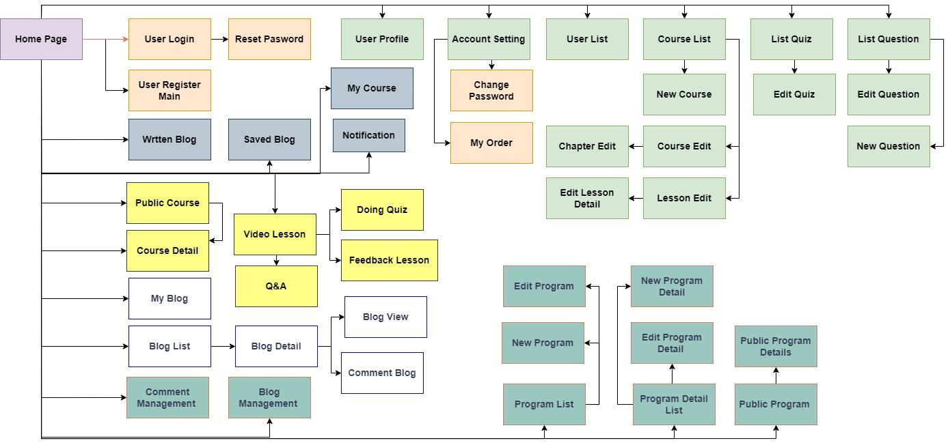

## 2. Functionalities

| **#** | **Feature** | **Use Case** | **Screen/Function** | **Screen/Function Details** |
| --- | --- | --- | --- | --- |
| 1 | System Admin | Course Route Management | Course Route Management | -This screen will allow Admin to create route course , route course item , course,... |
| 2 | System Admin | Add/Delete/Edit Program | New Program | -Create name route course , image , name route course 1 ,name route course 2 |
| 3 | System Admin | View Program List | Program List | -list each table of contents in each learning route but you can edit, delete, add |
| 4 | User Access | Public Programs | Public Programs | - Show users which learning routes, an overview of each learning path |
| 5 | User Access | Public Program Details | Public Program Details | -list each table of contents in each learning path |
| 6 | System Admin | Add/Delete/Edit Program | Edit Program | -Edit name route course , image , name route course 1 ,name route course 2 |
| 7 | System Admin | Add/Delete/Edit Program Details | New Program Details | -Create name route course item , item route course introduction , choose route course and courses |
| 8 | System Admin | Program details List | Program details List | --list each table of contents in each learning route but you can edit, delete, add |
| 9 | System Admin | Add/Delete/Edit Program Details | Edit Program Details | -This screen admin can change fields such as the name of the course table of contents, introduce the course table of contents and also change the courses. |
| 10 | User Access | View Profile | User Profile | This is the screen to help admin or expert create a new course. |
| 11 | User Access | Edit Information | Account Setting | The screen allows users to update personal information, avatars, ... |
| 12 | System Admin | User Management | User List | The screen that allows administrators to control who is in the site and update or delete users. |
| 13 | User Access | View My Blog List | Written Blogs | This is a screen help users review their published articles and can edit or delete. |
| 14 | User Access | View Blog Detail | Blog View | This is a screen help users see the details of a blog and can like or comment. |
| 15 | User Access | Cancel Order | My Order | This screen helps users to view their registered orders (courses). |
| 16 | User Access | Answer the question | Q&A | This screen helps users discuss lessons on the system. |
| 17 | System Admin | Manage comments | Comment Management | This screen allows the admin to manage the comment list on each blog. |
| 18 | User Access | New Account Registration | User Register | This is the screen used for users to register for an account after entering their name, phone (or email), password, ... |
| 19 | User Access | View Course Details | Course Detail Screen | Show the user the details of the course, here the user can see the details of each chapter and lesson of the course. |
| 20 | User Access | View Home Page | Home page | This is a screen to help users access the home page, view procourse and course, view notification of the  system or other members. |
| 21 | System Admin | Create New Course | New course | This is the screen to help admin or expert create a new course. |
| 22 | System Admin | View Course List | Course list | This is the screen to help admin or expert view a course list. |
| 23 | User Access | Login To the System | User Login | This is the screen used for users to login for an account after entering their name, phone (or email), password, ... |
| 24 | User Access | View Noifications | Notification | This is the screen used for users to see the notification |
| 25 | User Access | Write Blog | Blog Details | This is a screen to help users add, edit Blog information, linked from written Blog |
| 26 | User Access | View Blog List | Blog List | This is a screen that helps users see a list of their own Blogs and those of others |
| 27 | System Admin | View Course List | Course List | This is a screen to help admin see the course was create and delete them |
| 28 | System Admin | Edit Course | Course Edit | This is a screen help admin to edit detail courses |
| 29 | User Access | View Saved Blogs | Saved Blogs | This is a screen help user to see the blog they was saved and remove from page |
| 30 | User Access | Register The Course | Course Registration | This is the screen used for users to regis course |
| 31 | User Access | Learn through videos | Video Lesson | This is the screen used for users to learn by video |
| 32 | User Access | View Course Registered | My Course | This screen to helps users to view their courses. |
| 33 | System Admin | View Question List | List Question | This screen to helps admin to list All Question, filter quizlesson and delete question. |
| 34 | System Admin | View Question Details | Question Details | This screen to helps admin to create/edit a Question. |
| 35 | User Access | Doing Quiz | Doing Quiz | This screen helps the user to take the quiz after the lesson. |
| 36 | User Access | View Notes | See Notes | This screen helps the user to see the Notes when they want to note something from lesson |
| 37 | User Access | Edit Notes | Edit Notes | This screen helps the user to edit the Notes when they want to change something from lesson |
| 38 | System Admin | Manage blogs | Blog Management | This screen helps admin manage all blog on the system |
| 39 | System Admin | Edit Course | Course Edit | This screen help admin edit course which they want to edit |
| 40 | System Admin | Edit Lesson | Lesson Edit | This screen help admin edit lesson which they want to edit |
| 41 | User Access | Doing Feedback Lesson | Feedback Lesson | This screen helps the user to take the feedback in the lesson. |
| 42 | System Admin | Edit Chapter | Chapter Edit | This screen help admin edit chapter which they want to edit |
| 43 | System Admin | View Quiz List | List Quiz | This screen will allow Admin to see a list of quizzes |
| 44 | System Admin | Edit Quiz | Edit Quiz | This screen will allow Admin edit quiz |
| 45 | User Access | Change Password | Password Change | This is a screen to help users change their password with 3 parts including entering the old password, entering the new password and confirming the password. |
| 46 | User Access | Reset Password | Password Reset | This is the screen to help users reset their password after forgetting the password |

## 3. User Authorization

| **Screen** | **Customer** | **Admin** |
| --- | --- | --- |
| Reset password |  | X |
| Change password |  | X |
| User Profile | X | X |
| Settings Account Details |  | X |
| User List |  | X |
| Home page | X | X |
| New course |  | X |
| Public Courses | X | X |
| User Register |  | X |
| Course Details |  | X |
| User Login | X | X |
| View Notifications | X | X |
| New Program |  | X |
| Program List |  | X |
| Public Programs | X | X |
| Published Blog | X | X |
| Blog Details |  | X |
| Blog View | X | X |
| Written Blogs | X | X |
| Course List |  | X |
| Saved Blogs | X | X |
| Video Lesson | X | X |
| Course Registration | X | X |
| Edit Route Course |  | X |
| Public Program Details | X | X |
| New Route Course Item |  | X |
| My Order | X | X |
| Q&A | X | X |
| Course Edit |  | X |
| Blog Management |  | X |
| Lesson Edit |  | X |
| Chapter Edit |  | X |
| Feedback Lesson | X | X |
| My Course | X | X |
| List QuizLesson |  | X |
| New Quiz Lesson |  | X |
| Edit Quiz Lesson |  | X |
| Quiz Lesson | X | X |
| Comment Management |  | X |
| See note in video lesson |  | X |
| Edit note in video lesson |  | X |
| Public Programs | X | X |
| Edit Program Details |  | X |
| Course Route Management |  | X |
| List Quiz |  | X |
| Edit Quiz |  | X |
| Video Lesson | X | X |
| Blog Management |  | X |
| Edit Lesson Detail |  | X |

## 4. Entity Relationship Diagram

**Entities Description**

| **#** | **Entity** | **Description** |
| --- | --- | --- |
| 1 | Setting | Define and manage user roles and their associated permissions |
| 2 | Account | It typically contains data related to user authentication, authorization, and personal details |
| 3 | Course | It is responsible to stores information about courses |
| 4 | CourseRequirement | It is requirements about the course |
| 5 | CourseLearnWhat | What we have learned is shown in this table |
| 6 | RouteType | Type of learning route |
| 7 | RouteTypeItem | It is an item in the learning path |
| 8 | RouteTypeItemAndCourse | It is responsible for the reference to the course and RouteTypeItems |
| 9 | CourseRegister | The course the user has signed up for |
| 10 | Chapter | The chapter of a course |
| 11 | Lesson | The lesson of a chapter |
| 12 | Question | The question of a lesson |
| 13 | Answer | The answer of a question |
| 14 | CorrectAnswer | The correct answer of a question |
| 15 | Blog | It is archived for posts that the user has written |
| 16 | CommentBlog | It is archived for comments on Blogs |
| 17 | SavedBlog | It is stored for blog which have been saved |
| 18 | Notification | It is stored so that the notification has been notified from the system or other users |

# II. Functional Requirements

## 1. <<User Access>>

### a. <<User Login Screen>>

* *Function trigger: To use the function we go to the homepage, then click the login button in the upper right corner of the screen.*
* *Function description: This function is for every actor who wants to use many other functions of the website: admin, user, expert, etc. The purpose of this function is to allow the user to log in to their existing account on the system. The user will be prompted to enter their account name or email and password to access their account. If the login credentials are correct, the user will be granted access to their account and can start using the other functions of the website. The login details will be validated against the data stored in the database table "account" which contains details such as account name, email, password, phone number, Google ID, Facebook ID, and Github ID.*
* Screen layout:

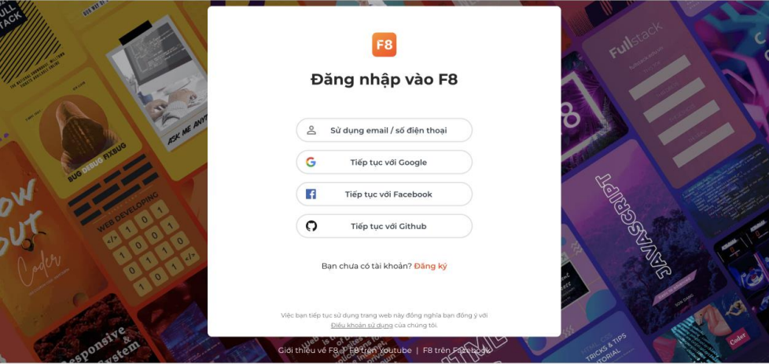

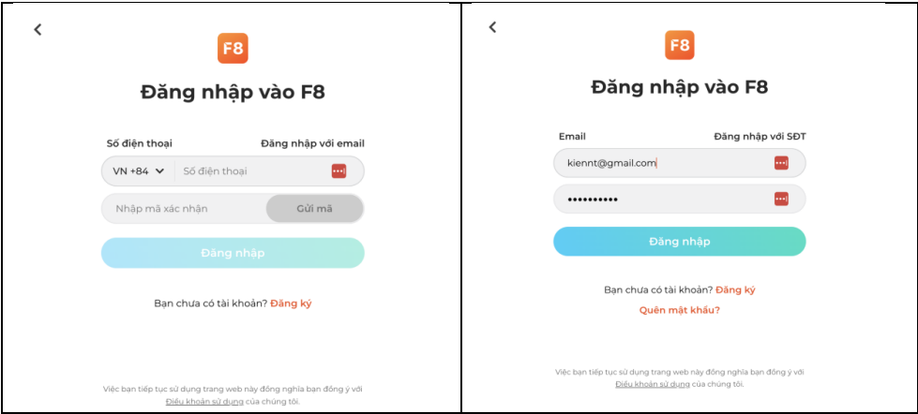

* *Function Details: After using the function, the system will check the user's entered credentials against the information stored in the database table "account". If the login credentials are correct, the system will grant access to the user's account and provide them with access to all the functions of the website. The system will also retrieve the account ID, account name, and avatar link associated with the user's account from the database and display it on the dashboard. This information is used to personalise the user's experience on the website. Any changes made to the user's profile or settings during their session will be saved to the database for future use.*

### b. <<Notification Screen>>

* Function trigger: can be triggered by various events such as a user interaction with the website (clicking a button or link), receiving data from an API endpoint, or a specific time interval.
* Function description: This function sends notifications to users about important updates, messages, or actions related to their account or the website. It accepts parameters such as the user's ID, type of notification, and notification content. Through API calls or third-party services, it sends notifications via email, SMS, or push notification. This improves the user experience by providing timely and relevant notifications.
* Screen layout:

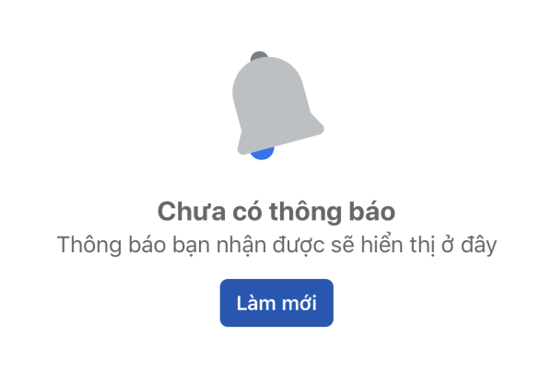

* Function Details: Notifications are messages or alerts that inform users about updates or events. They come in various forms, such as pop-up alerts, emails, texts, or push notifications on mobile devices. Notifications provide timely information to keep users informed and engaged with the software, allowing them to take appropriate action. Their function includes organising tasks, tracking progress, responding quickly to updates, and improving user engagement and retention.

### c. <<User Register Screen>>

* Function trigger: To use the function we go to the homepage, then click the register button in the upper right corner of the screen
* Function description: This function is for every actor who wants to use many other functions of the website: admin, user,expert,... The purpose is to create an account for the first time on the system. After registration, the data will be saved to the database table "account" with account name, password (if any), Email, Phone, GoogleID, FacebookId, GithubId.
* Screen layout:

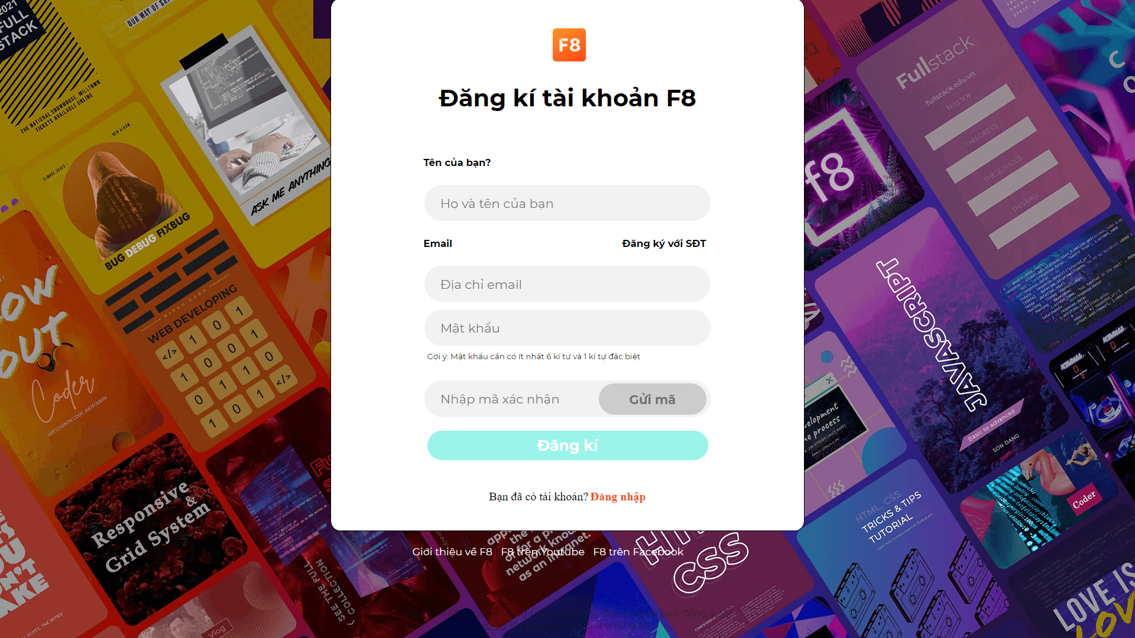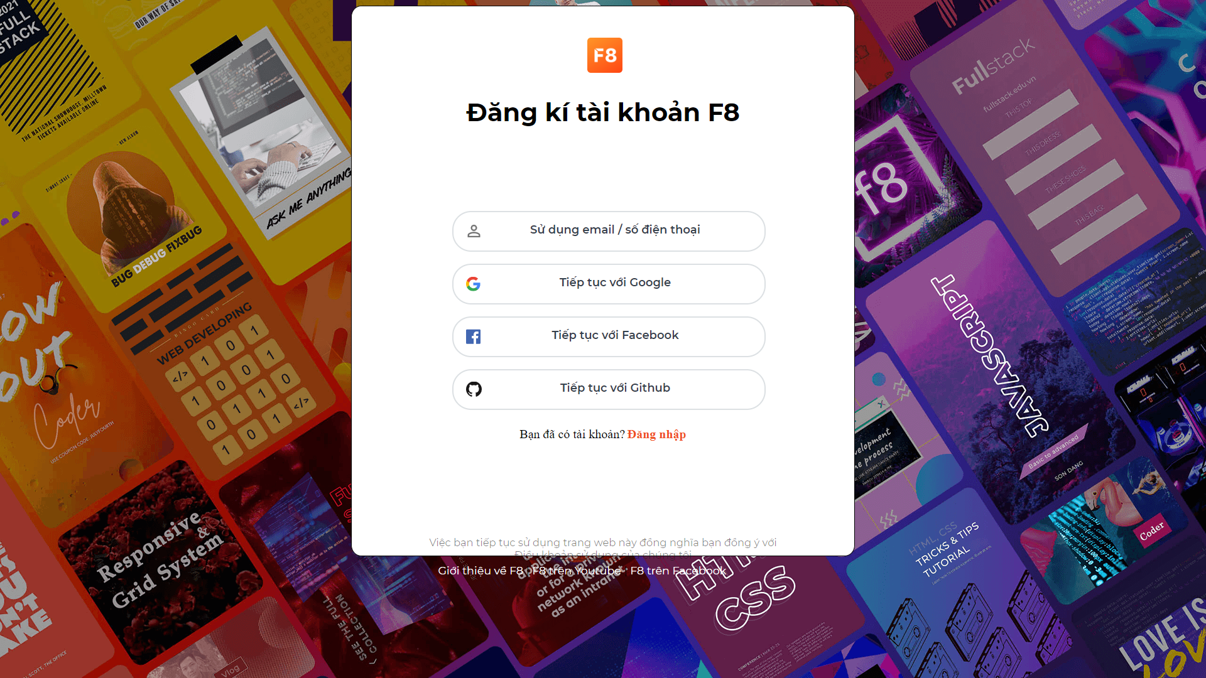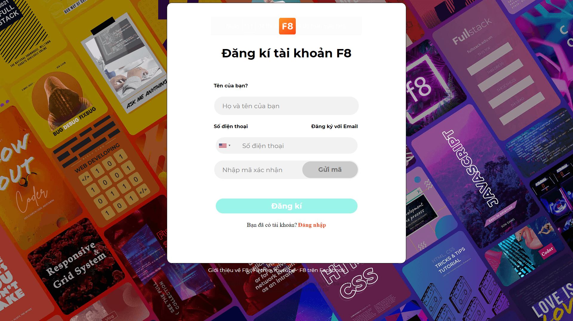

* Function Details: After using the function, the system will only save the information the user entered in the registration. If with registered items by link, the system will receive your account Id, account name, and avatar link. Then save this information to the database for later login

### d. <<Course Detail Screen>>

* Function trigger: To use the function you will click on the "Xem khóa học" button in the course bars displayed on the homepage or on your personal page if you have registered for the course.
* Function description: This function is for the User, they help the user to see the details of the courses that have been published on the website
* Screen layout:

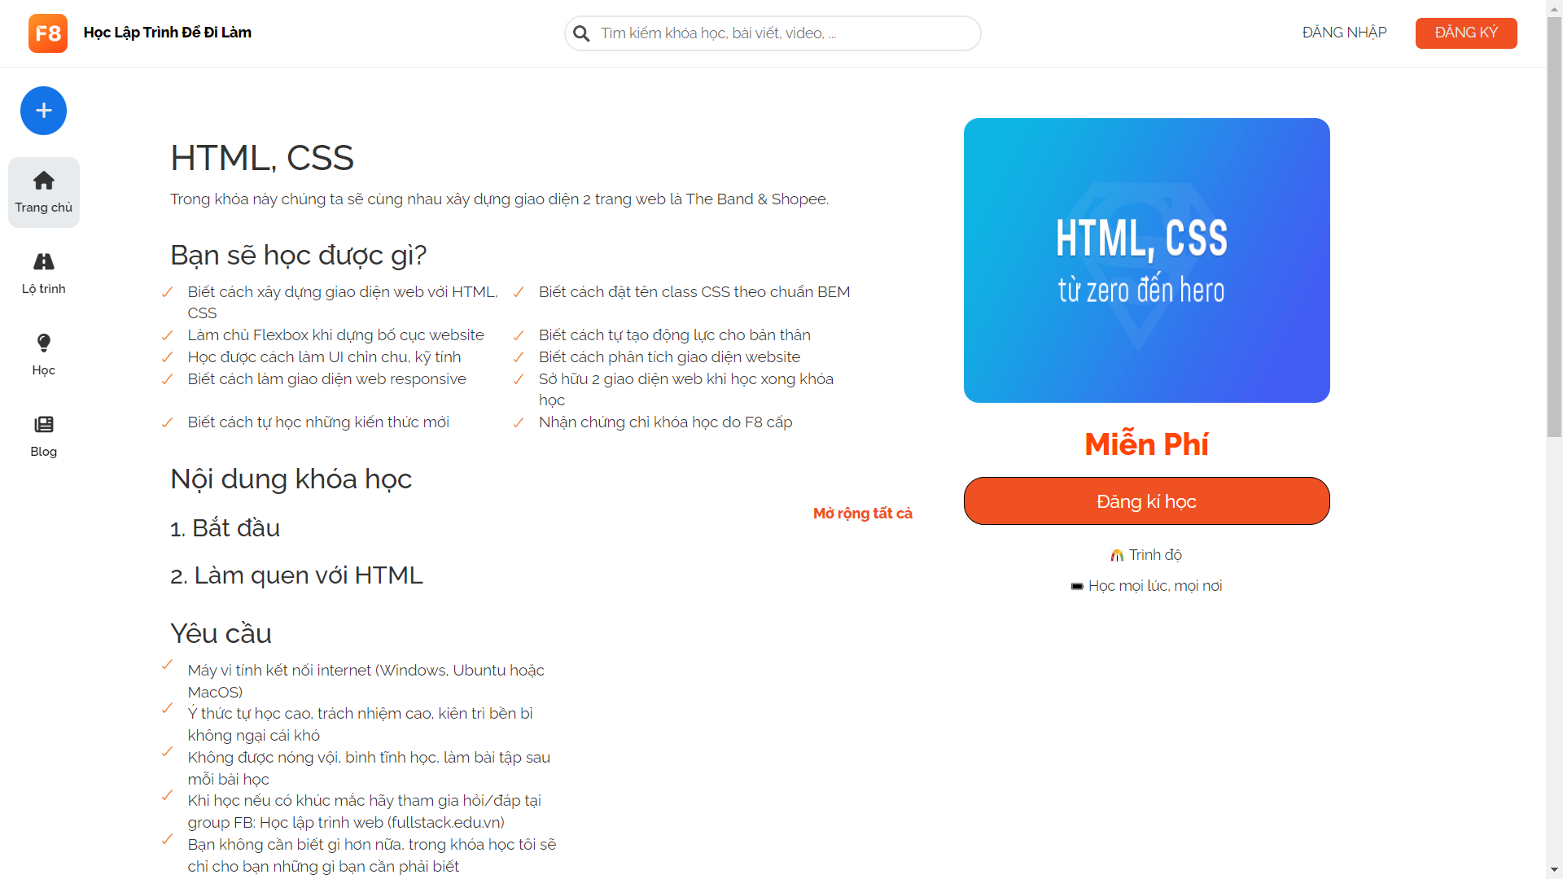

* Function Details: After pressing the "Xem khóa học" button, the function will use the courseId passed to the page to query select related tables such as "course, courseDetail, chapter, lesson,..." from there to get the information and display it on the screen. You can view the lessons of the chapter by clicking on the chapter name or "Mở rộng tất cả"

### e. <<User Profile Screen>>

* Function trigger: To use this function, click on the avatar icon in the upper right corner of the screen and then click on "Trang cá nhân".
* Function description: This function is for users, it allows users to view information such as name, bio, attendance time, courses attended, cover photo update.
* Screen layout: 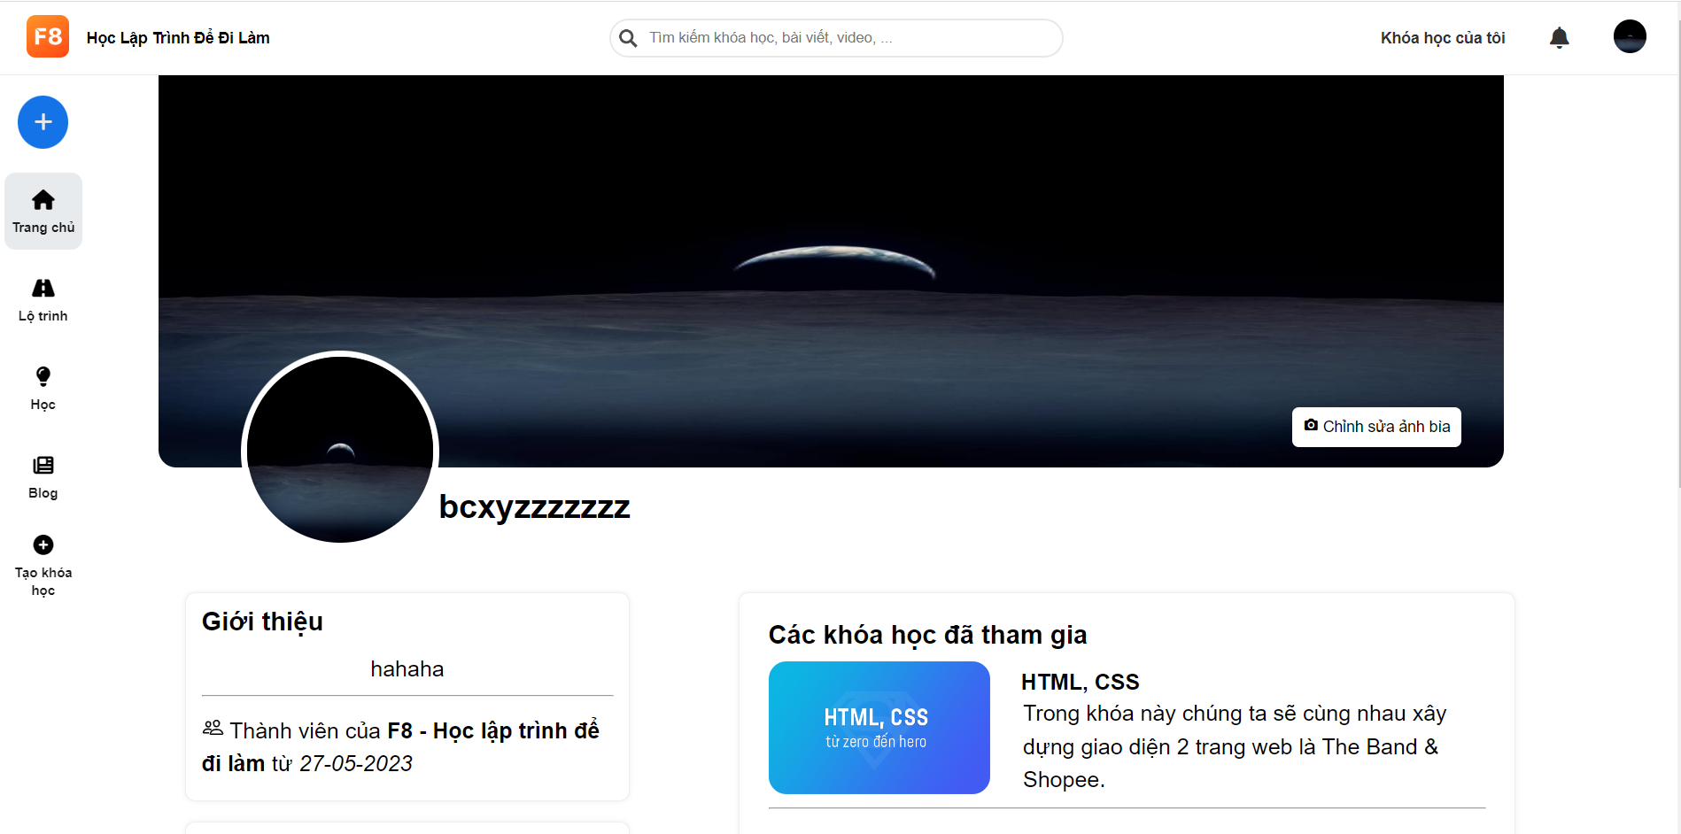
* Function Details: After clicking "Trang cá nhân", the function will get the user's ID from the Session and then use the ID to get the user's data from the database such as name, cover photo, bio, join date, course attended,... and then displayed on the screen.

### 

### f. <<Setting Account Details Screen>>

* Function trigger: To use this function, click on the avatar icon in the upper right corner of the screen and then click on "Cài đặt".
* Function description: The function allows users to update personal information such as username, full name, email, phone number, avatar, …
* Screen layout: 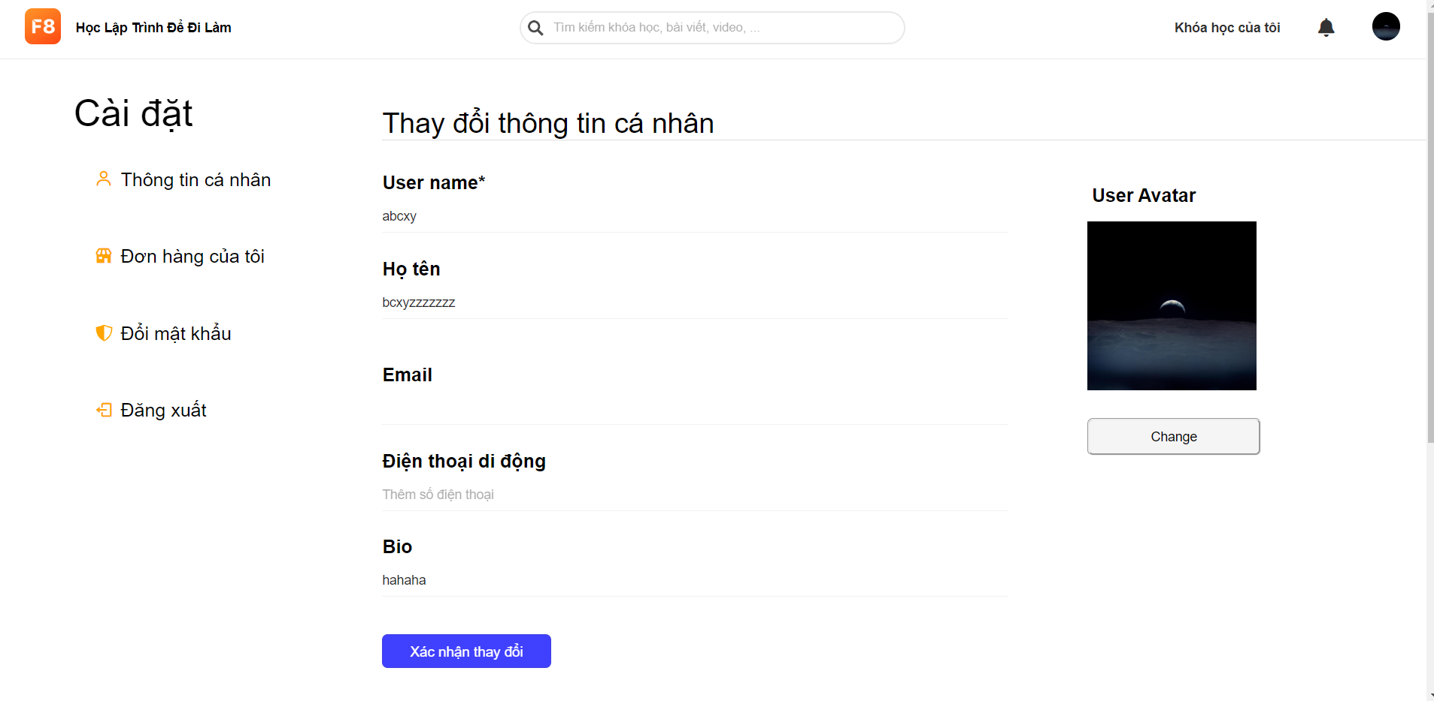
* Function Details: After clicking "Cài đặt", the function will get the user's ID from the Session and then use the ID to get the user's data from the database like name, profile picture, bio, email, and phone number ,... and then displayed on the screen.

### g. <<Homepage Screen>>

* Function trigger: To use the function we just run the project.
* Function description: This function is for every actor who wants to use many other functions of the website: admin, user,expert,... The purpose of displaying the homepage when the user accesses, displaying the pro course and the course, receiving notifications of the system and other members. Authorise these actors when accessing the web.
* Screen layout:

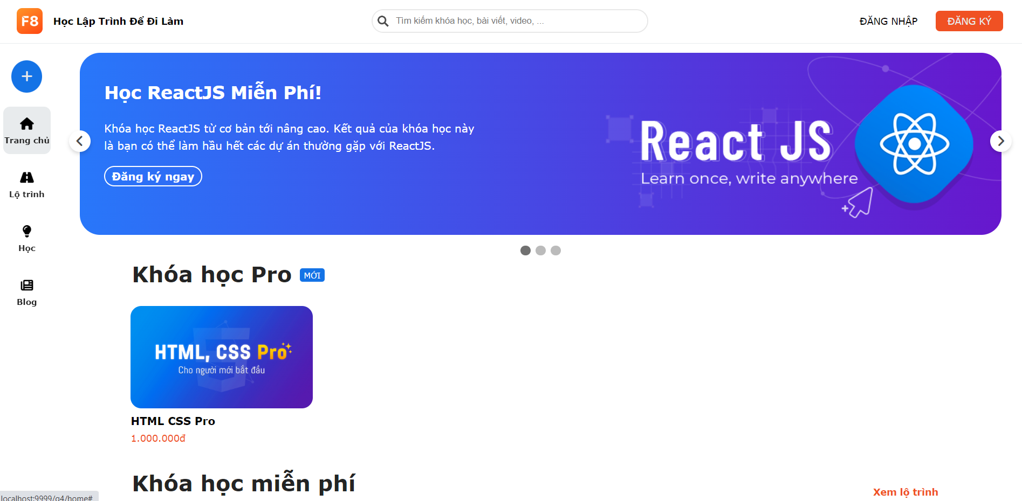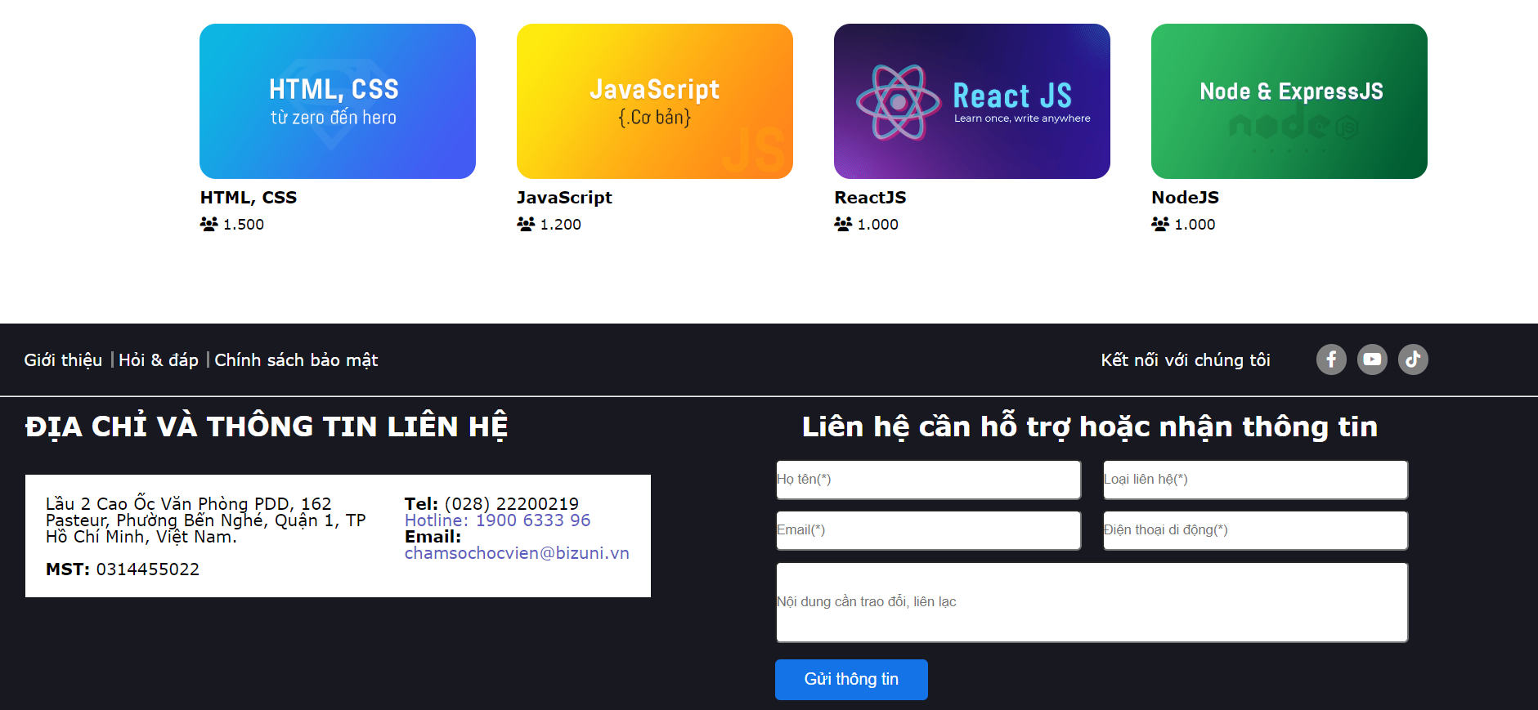

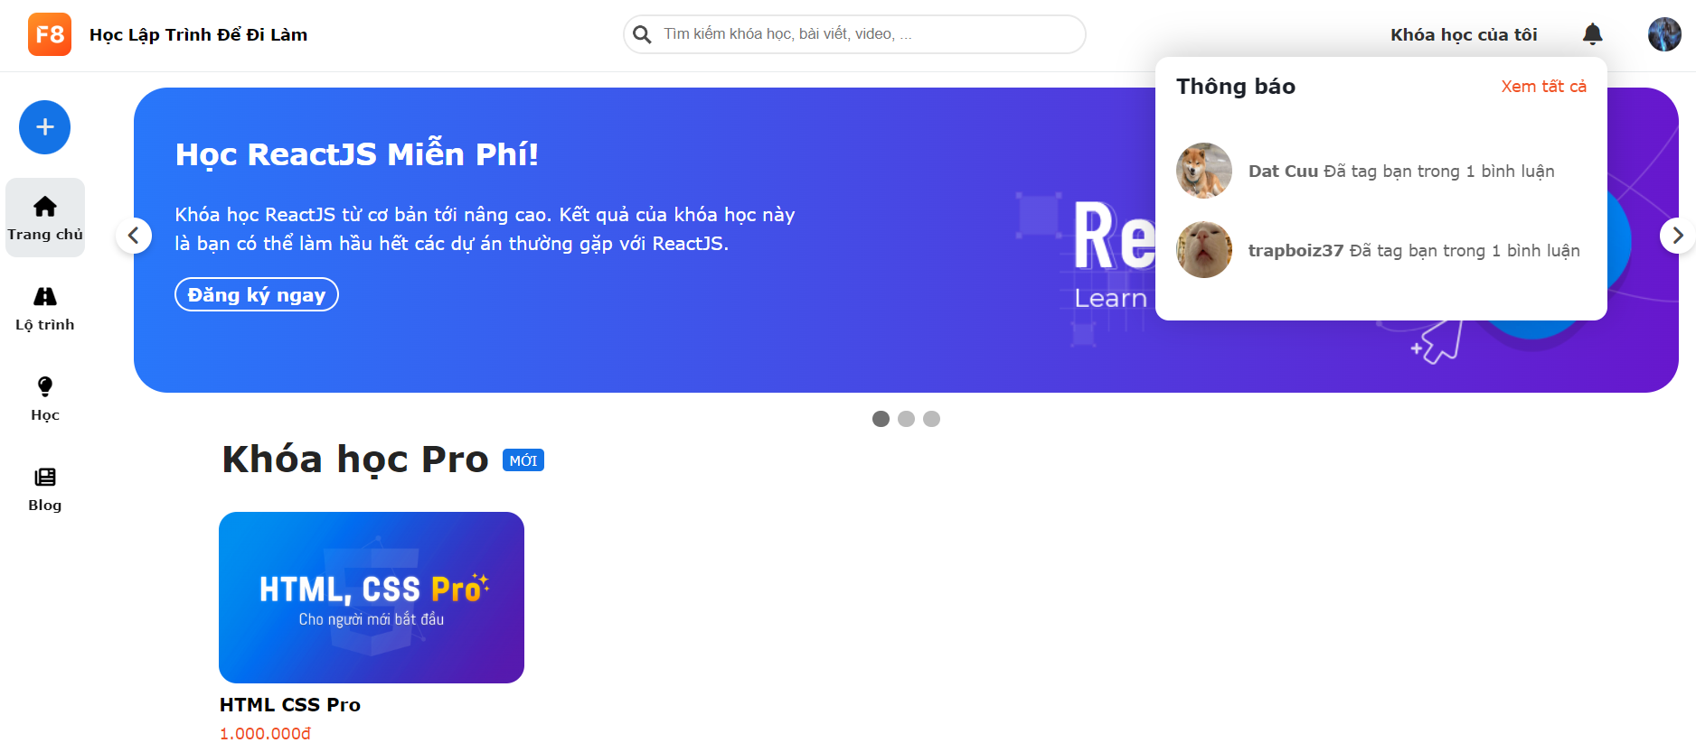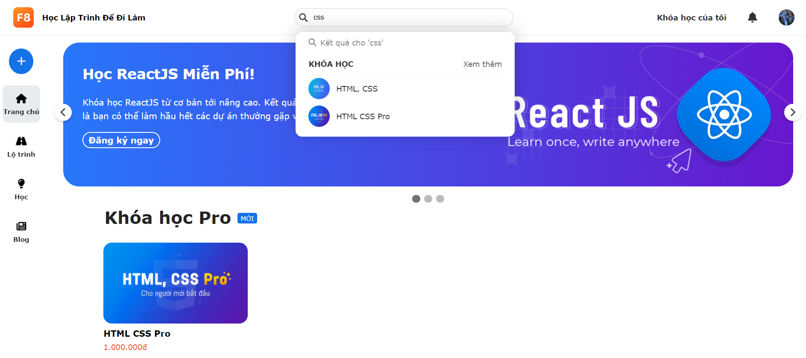

* Function Details: The function will get the user's ID from the Session and then use the ID to get the user's data from the database such as name, cover photo, bio, join date, course attended,... Grant the account permission when accessing the web to display the correct features.

### h. <<Course List Screen>>

* Function trigger: To use this function, we go to the Home page and find the course in the search bar then click on "Xem thêm".
* Function description: This function is for every actor who wants to use many other functions of the website: admin, user,expert,... Purpose of course listing and course search by title.
* Screen layout:

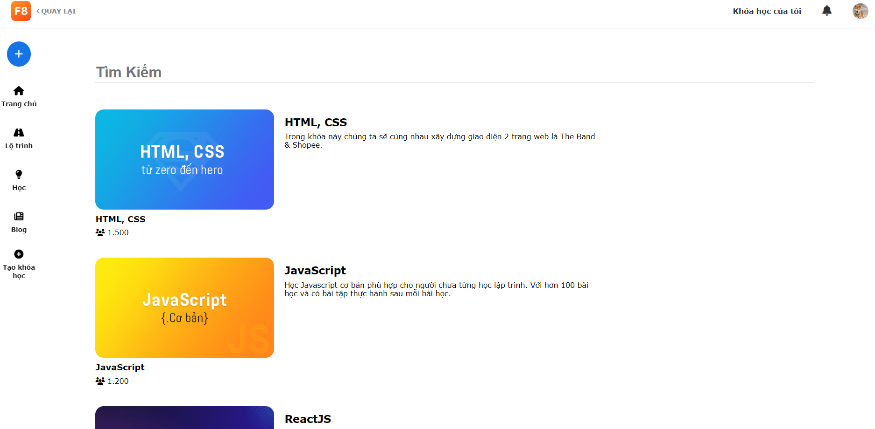

* Function Details: After clicking "Xem thêm", the function will get a list of courses by title from the database and display information such as title, description, number of people who join the course...

### i. <<Change Password Screen>>

* Function trigger: To use this function we must log in first then click on the avatar in the upper right corner of the screen then click "Thay đổi mật khẩu".
* Function description: This function is for every actor who wants to use many other functions of the website: admin, user,expert,... The purpose of the function is to change the user's password.
* Screen layout:

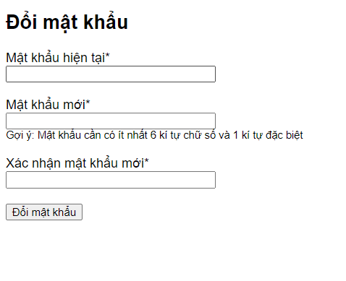

* Function Details: After clicking "Thay đổi mật khẩu" ,the function will allow the user to input the new password. After clicking the “Đổi mật khẩu” button at the bottom, the function will change the user’s password.

### 

### j. <<Reset Password Screen>>

* Function trigger: To use this function we have to click “Đăng nhập” -> “Sử dụng email/Số điện thoại” -> “Đăng nhập với email” -> “Quên mật khẩu”.
* Function description: This function is for every actor who wants to use many other functions of the website: admin, user,expert,... The purpose of the function is to reset the user's password.
* Screen layout:

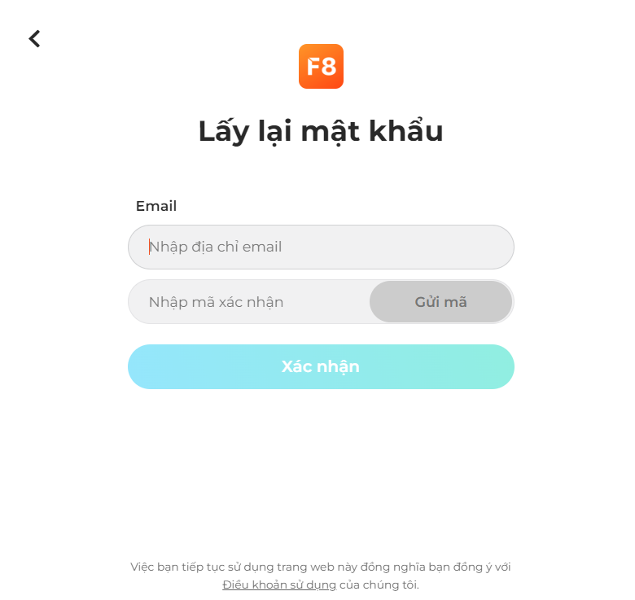

* Function Details: After pressing "Gửi mã", the function will send the code to the user's email, enter the code to reset the password

### k. <<Written Blogs Screen>>

* Function trigger: To use this function, click on the avatar icon in the upper right corner of the screen and then click on “Bài viết của tôi”.
* Function description: This function allows users to review their published blogs and edit or delete their own blogs.
* Screen layout:

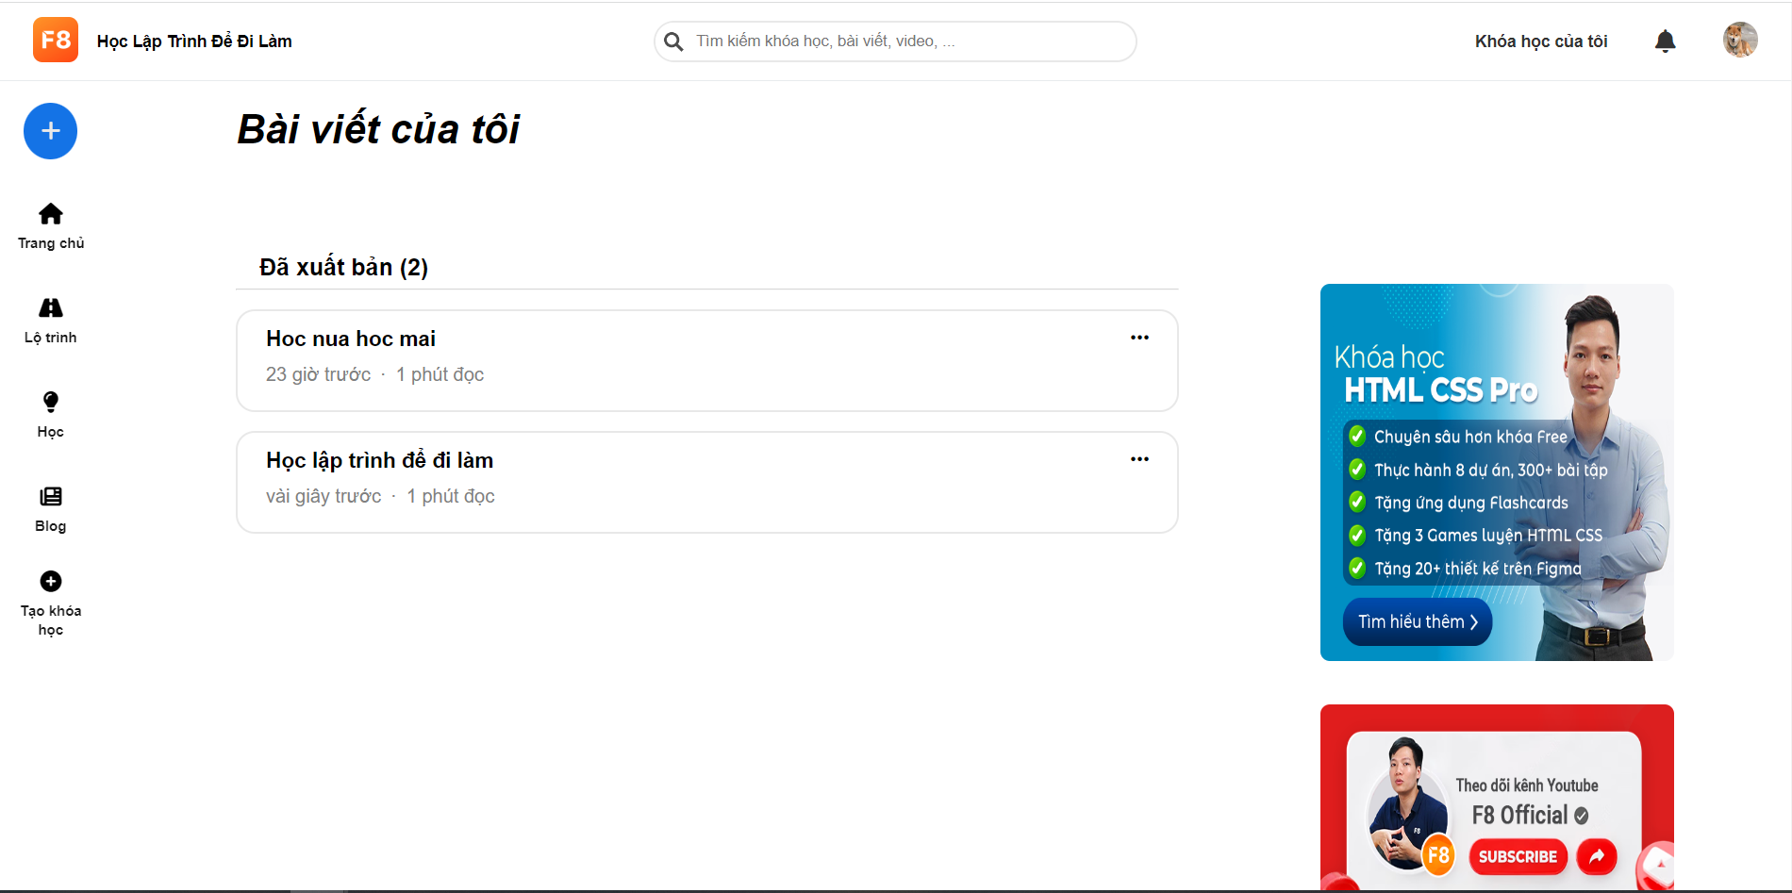

* Function detail: After clicking on "Bài viết của tôi", the function will get a list of the user's published blogs and display on the screen information such as title, publication time, number of minutes read, and number of blogs. published,...

### l. <<Blog View Screen>>

* Function trigger: To use this function, click on the post's title in the Blog List Screen, Written Blogs Screen, or Blog Saved Screen.
* Function description: The function allows the user to see everyone's published blogs, the user can like, comment on the blog, or can save the blog.
* Screen layout:

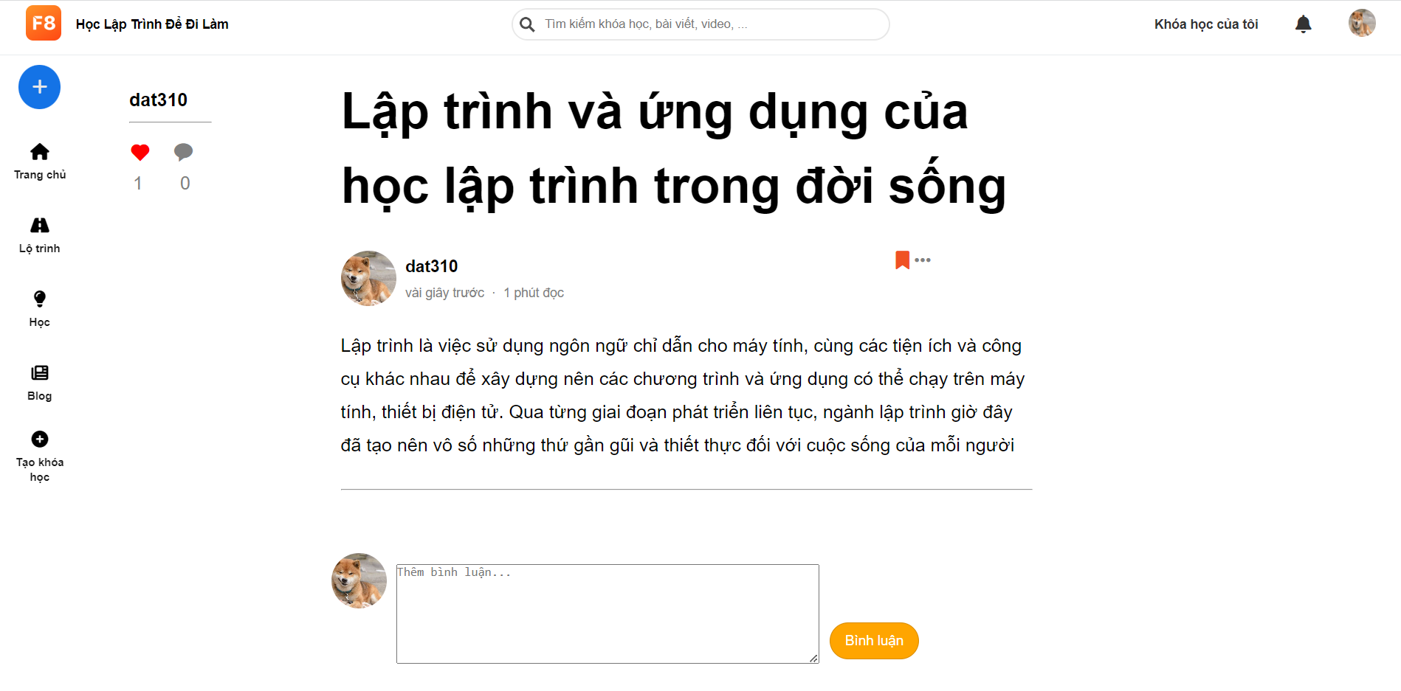

* Function Detail: When accessing, the function will get details about the blog from the database and then display information such as title, content, number of likes, comments, etc.

### m. <<Blog Details>>

* Function trigger: To use this function, click on the new blog icon in the top of the sidebar.
* Function description: This function allows users to add, edit Blog information, linked from written Blog.
* Screen layout:

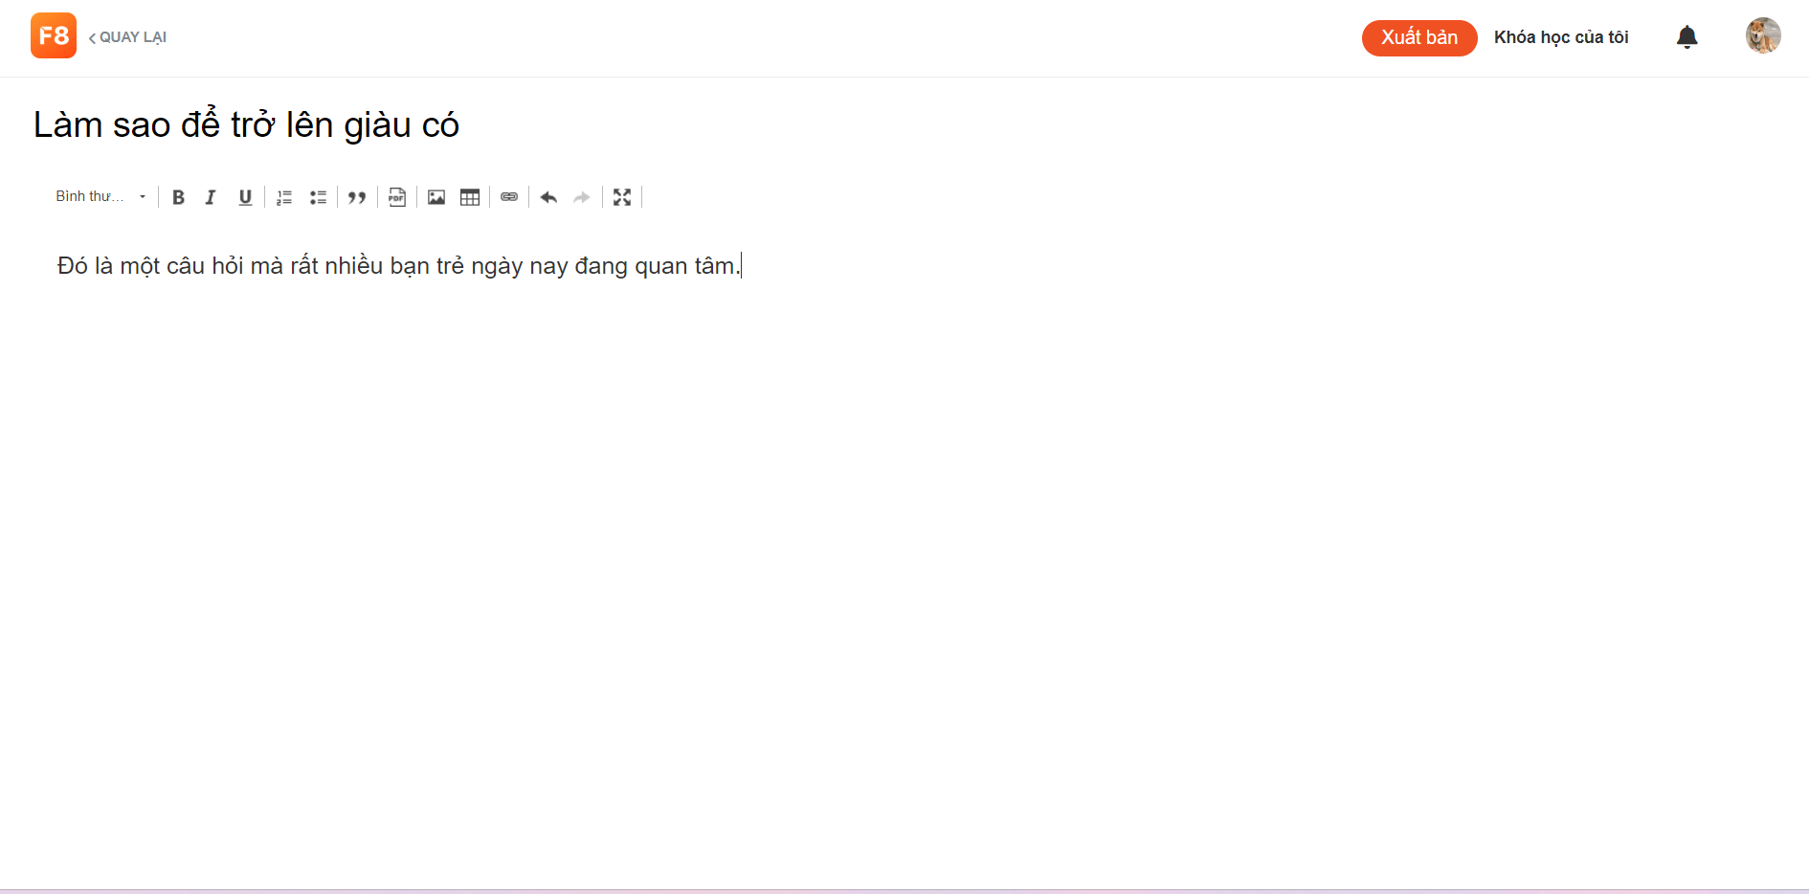

* Function detail: After clicking on Blog Details, the function will allow users to add Blog. After writing the title and content then click the ‘Xuất bản’ button. A new Blog will be created. Users can edit their Blog by clicking Edit Blog on the top of their blog.

### n. <<Blog List>>

* Function trigger: To use this function, click on the blog icon in the sidebar.
* Function description: This function allows users to view blogs written by themselves and others. Users can save their favourite Blog.
* Screen layout:

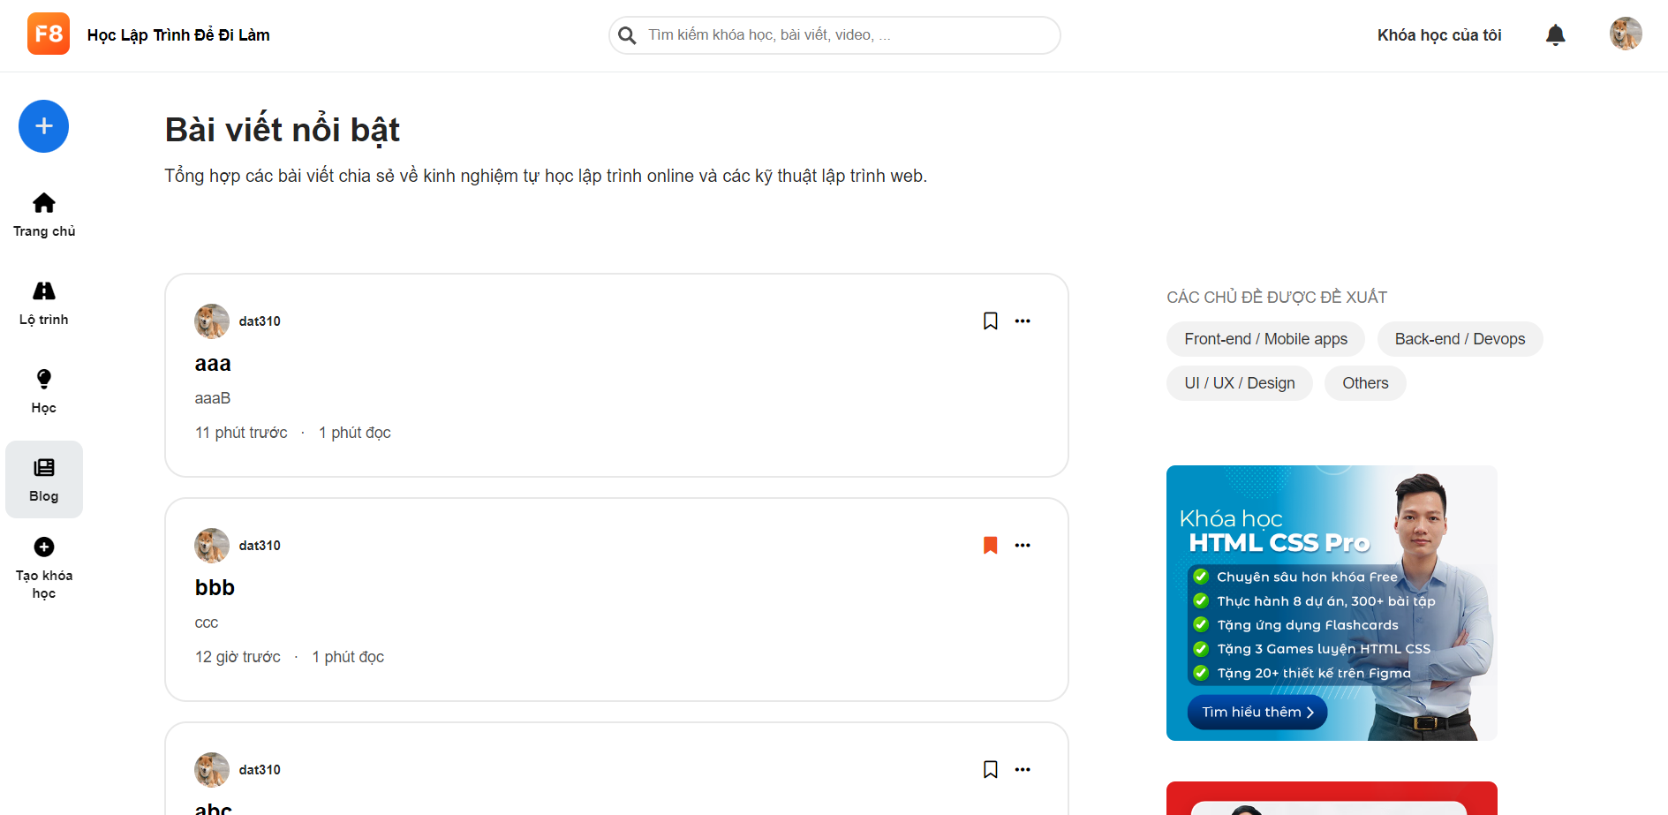

* Function detail: After clicking on the Blog icon in the sidebar, the function will allow users to view blogs written by themselves and others. Blogs will display title, content, image, creation time and reading time. After clicking the favourite icon, the Blog will be saved to Saved Blogs.

### o. <<Blog Saved>>

* Function trigger: To use the function, click on the avatar, then click on the item "Bài viết đã lưu".
* Function description:This function allows the user to review the blogs that the user has saved and can delete articles from this saved section.
* Screen layout:

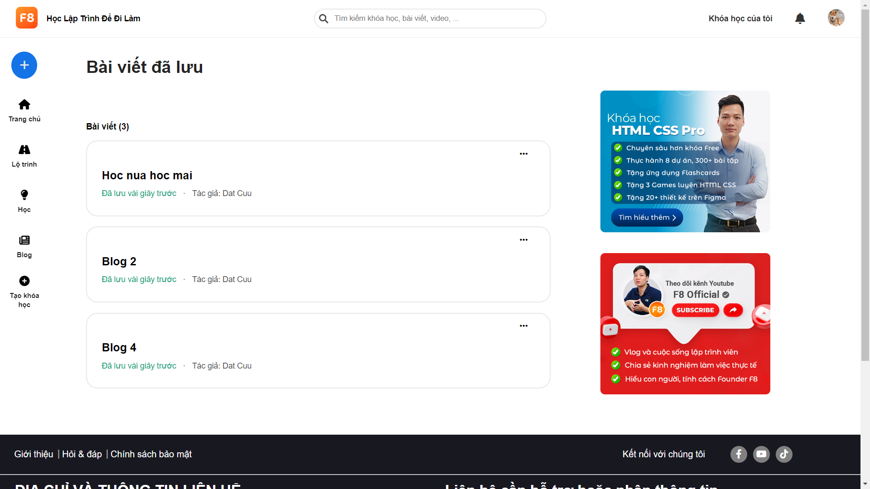

* Function detail: After entering the page with the description above, one can see the saved articles items displayed with the title, time of saving the article, author. After clicking the three-dot button, you can delete the post from the saved item

### p. <<Learn path screen >>

* Function trigger: To use this function, click on the Lộ trình icon in the sidebar.
* Function description: This screen will give us the name and general information about the learning route
* Screen layout:

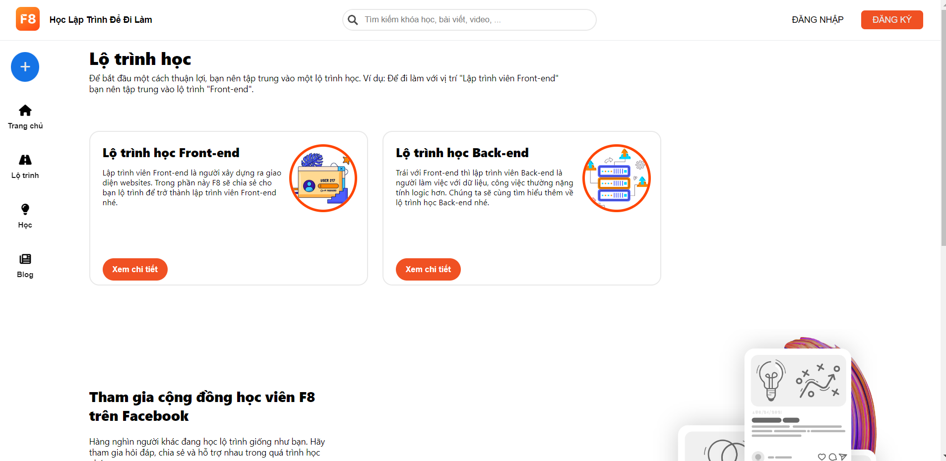

* Function detail: After the user selects the Learning Path on the sidebar, the user can view the learning routes such as name, general introduction, …

### q. <<Detail learn path screen >>

* Function trigger:
* to get this screen, the user selects VIEW DETAILS of the learn path screen.
* Function description:
* This screen has a lot of courses and many sections of the learning path
* Screen layout:

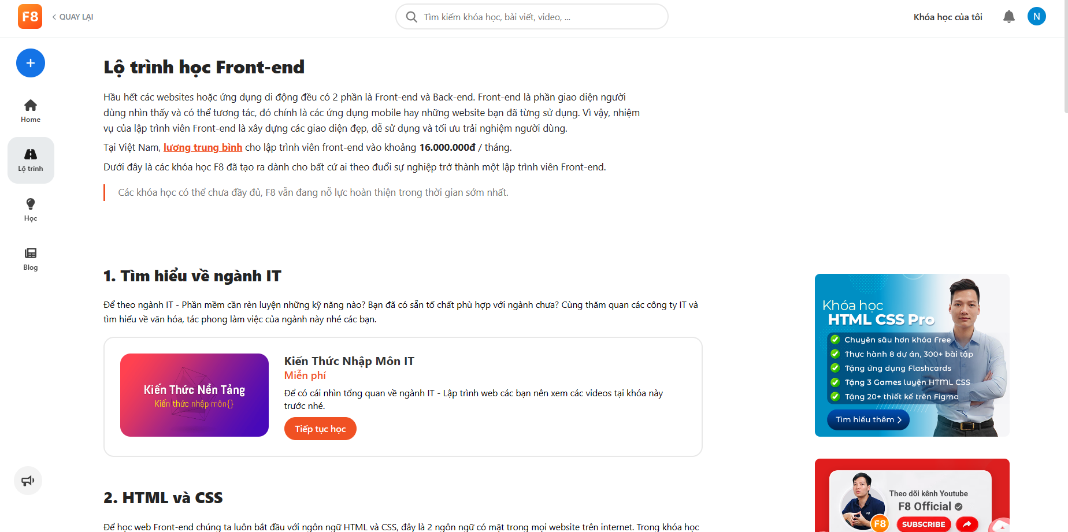

* Function detail: This screen includes the name of the course and its details. In this course there are many items arranged in order from easy to difficult. In each section there is course name, course photo and course details like price and course information

### r. <<Course Registration>>

* Function trigger: To use this function, Go to the course section, then click on any course that the user wants to learn, click "đăng kí học"
* Function description: This function allows users to register courses to learn.
* Screen Layout:

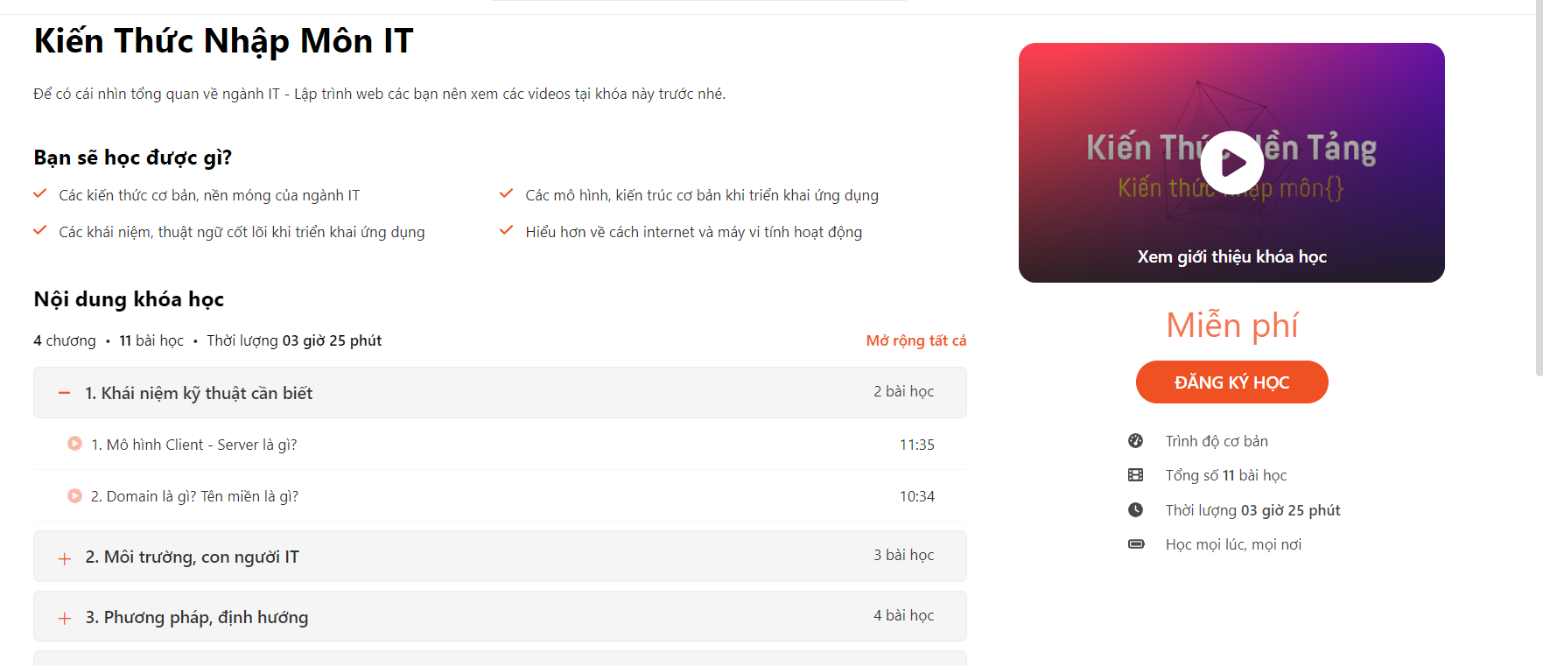

* Function Details: After clicking “đăng kí học”, The function will confirm that you have registered for the course, it will show the video to learn.

### s. <<Video Lesson>>

* Function trigger: To use this function, Register for a course, then click "khóa học của tôi" in the right corner of the screen
* Function description: This function allows users to learn registered courses through videos
* Screen Layout:

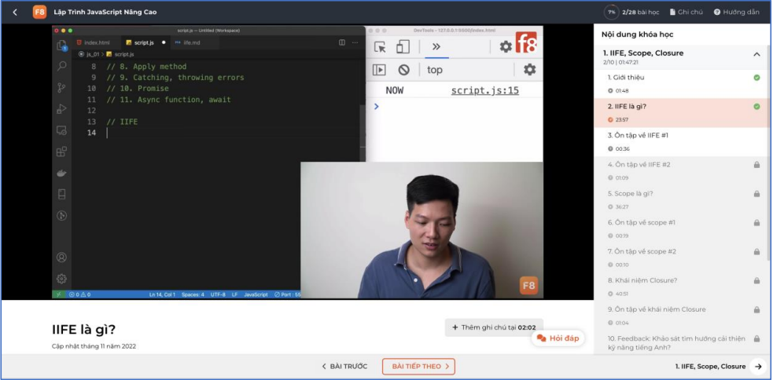

* Function Details: After clicking “khóa học của tôi”, The function will switch to a screen containing the titles of the course, clicking will show the video to learn.

### t. <<My Order screen>>

* Function trigger: To use this function, users visit the website select "Cài đặt" then select "Đơn hàng của tôi".
* Function description: This function allows users access to view the orders (courses) they have registered. It allows users to filter orders by order status, search for orders by course name, and cancel orders.
* Screen layout:

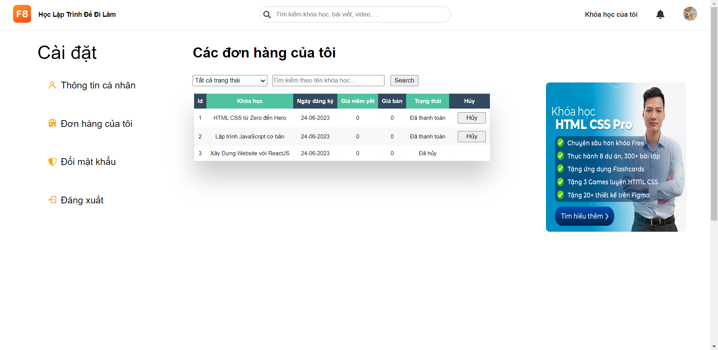

* Function details: After accessing, the function will retrieve a list of orders from the database and display information such as name, price, registration time, order status, etc.

### u. << Q&A screen>>

* Function trigger: To use this function, the user accesses the website to select the lesson and then clicks the "Hỏi đáp" button.
* Function description: This function allows users to access, it allows users to ask questions about the lesson, answer other users' questions about the lesson.
* Screen layout:

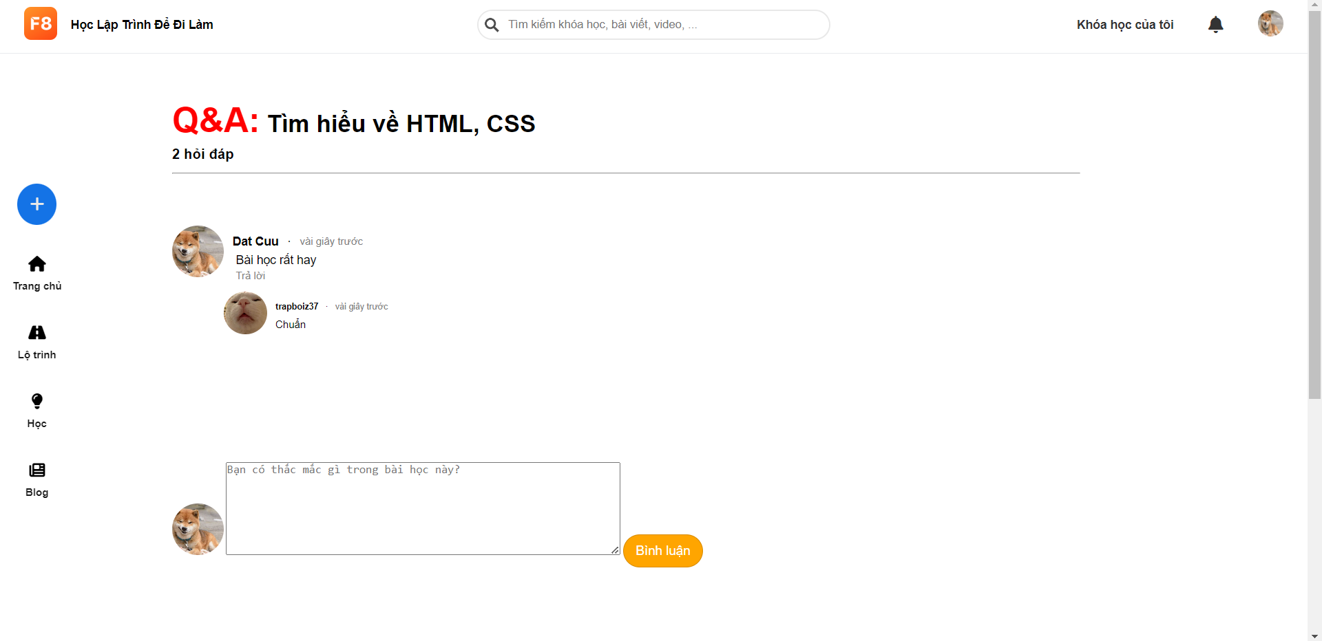

* Function details: After accessing the Q&A of the lesson, the function will get the list of questions and responses of that course from the database to display on the screen.

### v. << My Course screen>>

* Function trigger: To use this functionality, the user goes to the website and clicks on 'Khóa học của tôi' on the Header and then clicks on 'Xem thêm'.
* Function description: This function allows the user to view the registered course and registered time.
* Screen layout:

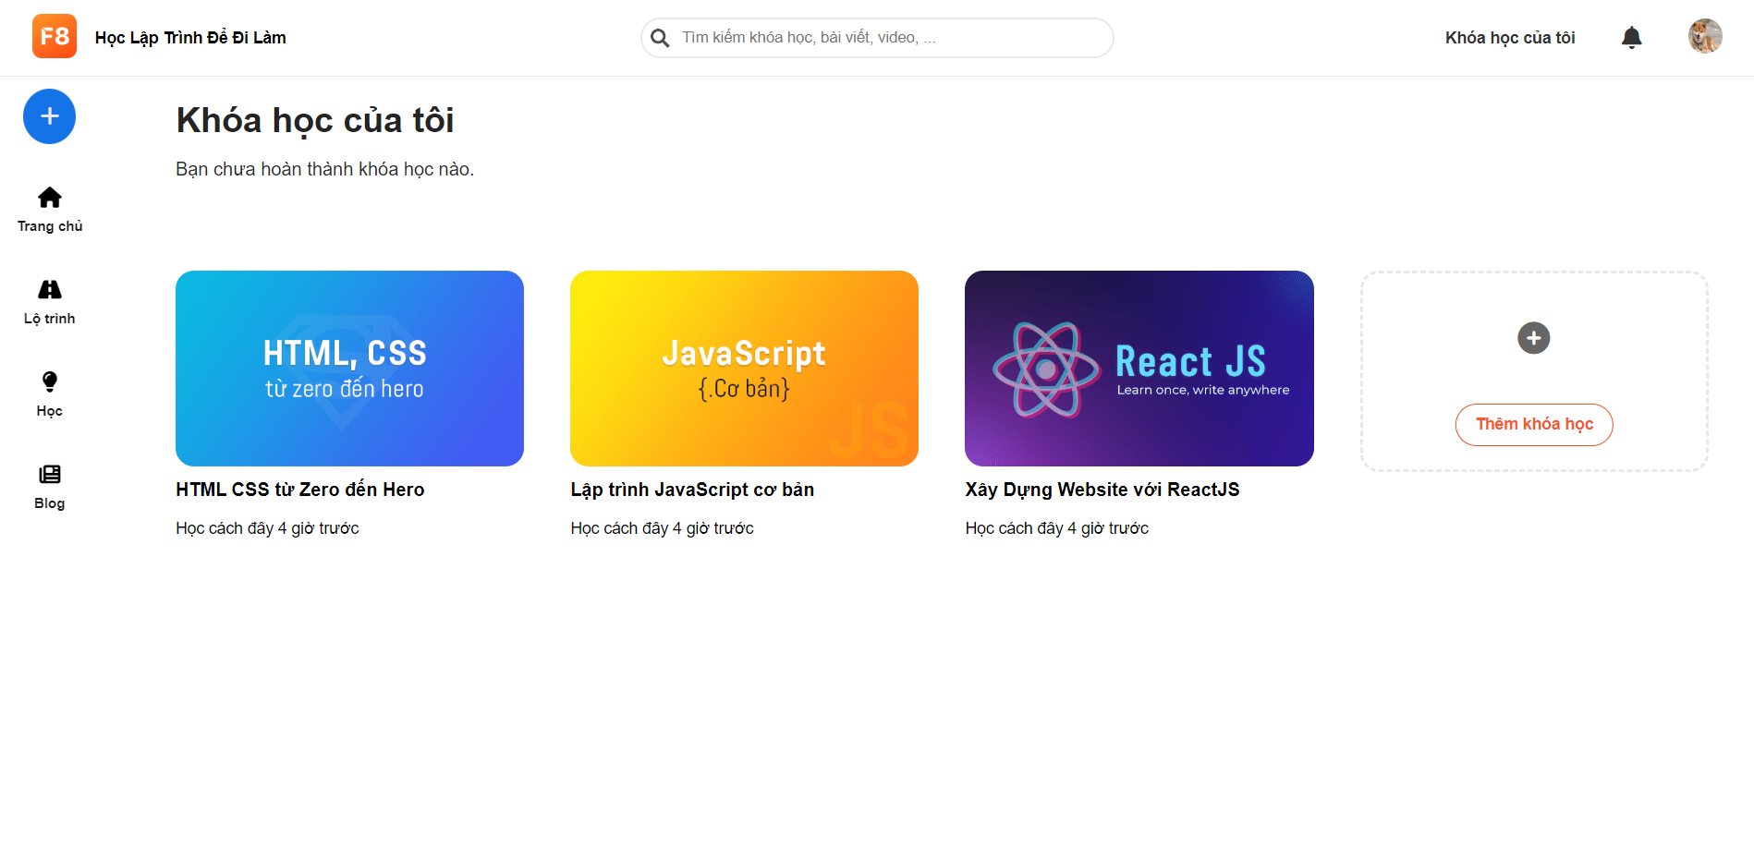

* Function details: After accessing the My Course, the function will get the list of courses, time registered and show that on the screen.

### w. << Doing Quiz Lesson screen>>

* Function trigger: To use this functionality, the user goes to the website and clicks on their registered course then clicks on the lesson type quiz.
* Function description: This function allows users to view the quiz by lesson, take the quiz, see the explanation and see the true false of the question.
* Screen layout:

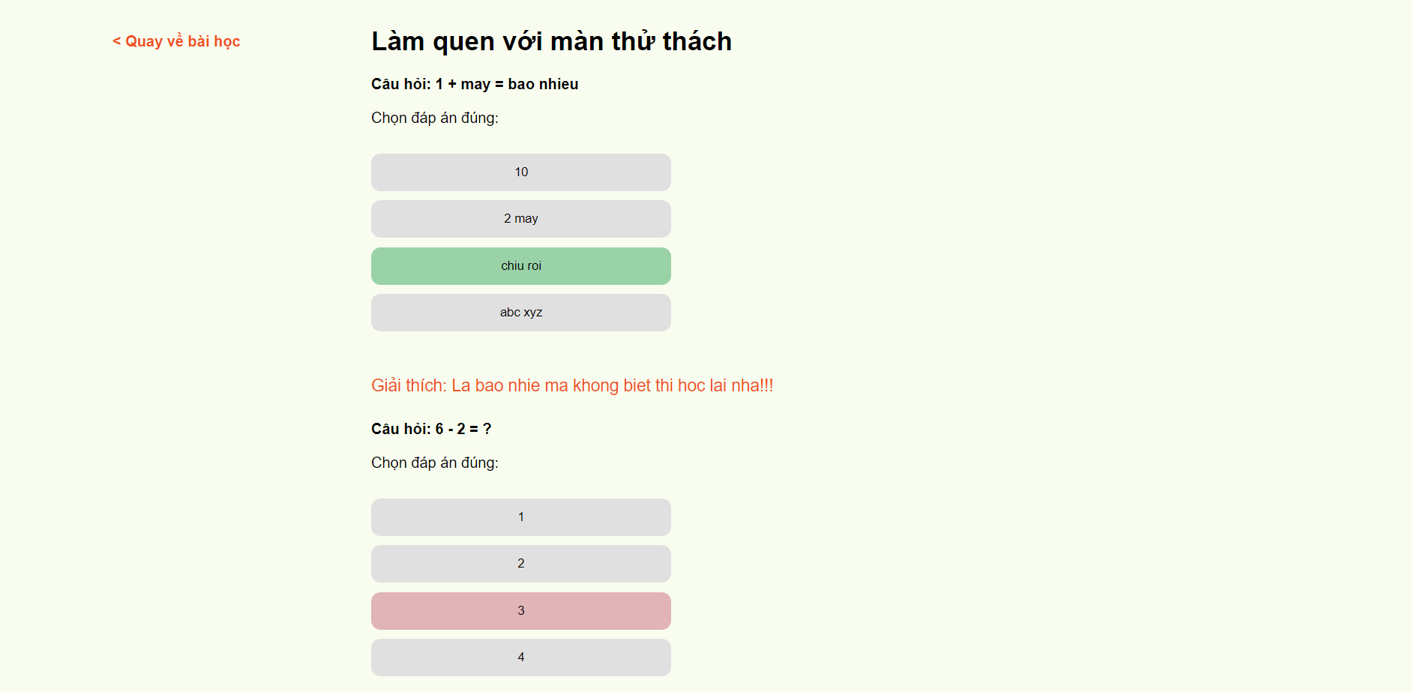

* Function details: After accessing the Doing Quiz Lesson, this function will get a list quiz by the lesson and show that on the screen, users can take the examination and view explanations and see the true or false of the quiz.

### x. <<Feedback Lesson screen>>

* Function trigger: To use this functionality, the user goes to the website and clicks on their registered course then clicks on the lesson type feedback.
* Function description: This function allows users to view the feedback by lesson, doing feedback and sending feedback.
* Screen layout:

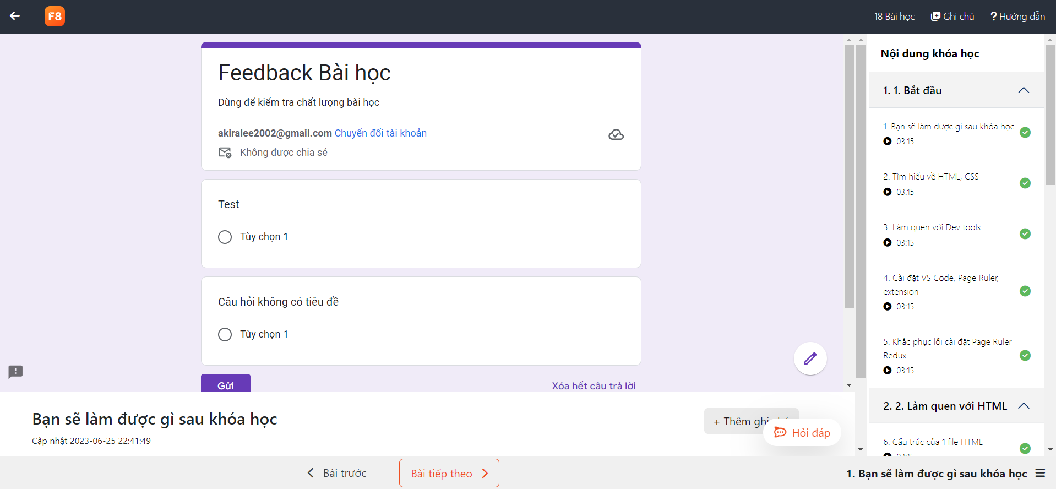

* Function details: After clicking the lesson has type “feedback”, the system displays feedback and users will rate it to post it here .

### y. <<Note Viewing screen>>

* Function trigger: To use this functionality, the user goes to the website and clicks on their registered course then clicks on the lesson and click on “Ghi Chú” button
* Function description: This function allows users to view the note that they noted when they learn in the lesson.
* Screen layout:

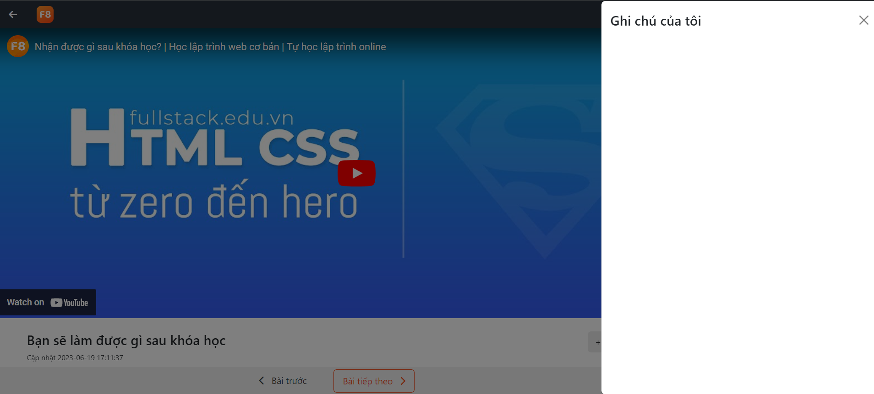

* Function details: After accessing the See note, this function will get a list of notes by the lesson and show that on the screen, users can take the view of the notes they noted before.

### z. <<Note Editing screen>>

* Function trigger: To use this functionality, the user goes to the website and clicks on their registered course then clicks on the lesson and click on “Thêm Ghi Chú” button
* Function description: This function allows users to add the note that they see some knowledge in the lesson is useful to remember.
* Screen layout:

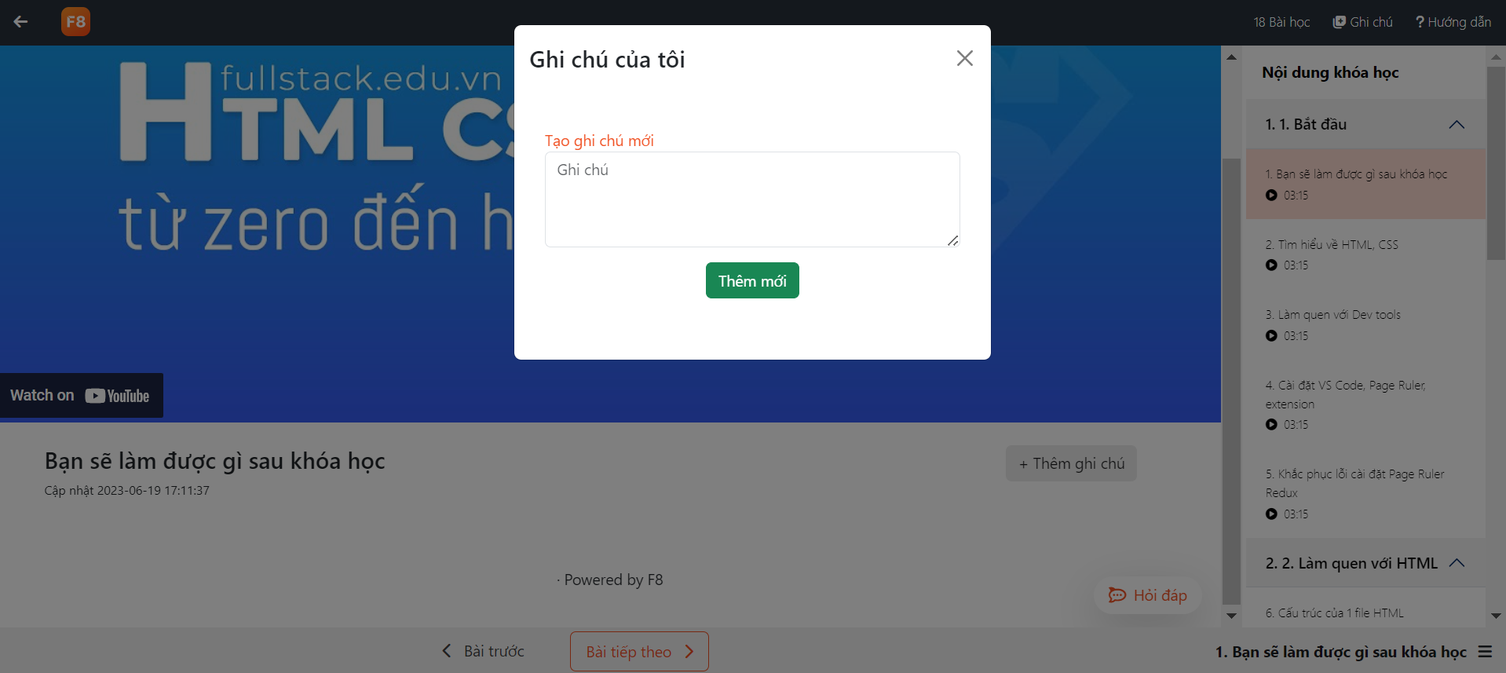

* Function details: After accessing the Edit note, this function will bring up a table where we can add memorable notes to the notes view.Users can edit or delete that note in the note view panel.

### z+. <<Learn path detail screen>>

* Function trigger: o use this function, users click on the learning route icon, then click "xem chi tiết"
* Function description: This function helps users to view their detailed study schedule
* Screen layout:

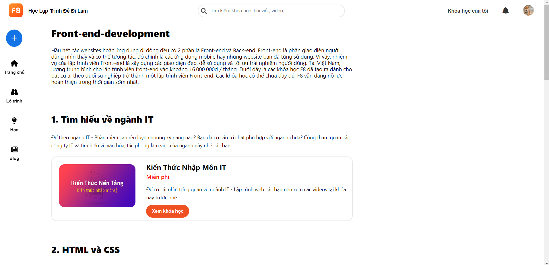

* Function details: In this course, users can view the information of each table of contents of the learning route and the courses in it

## 2. System Admin

### a. <<User List screen>>

* Function trigger: To use this function, click on the avatar icon in the upper right corner of the screen and then click on "Danh sách người dùng".
* Function description: This function only admin has access, it allows to view the list of users in the site, filter users by actor, update actors and delete users.
* Screen layout: 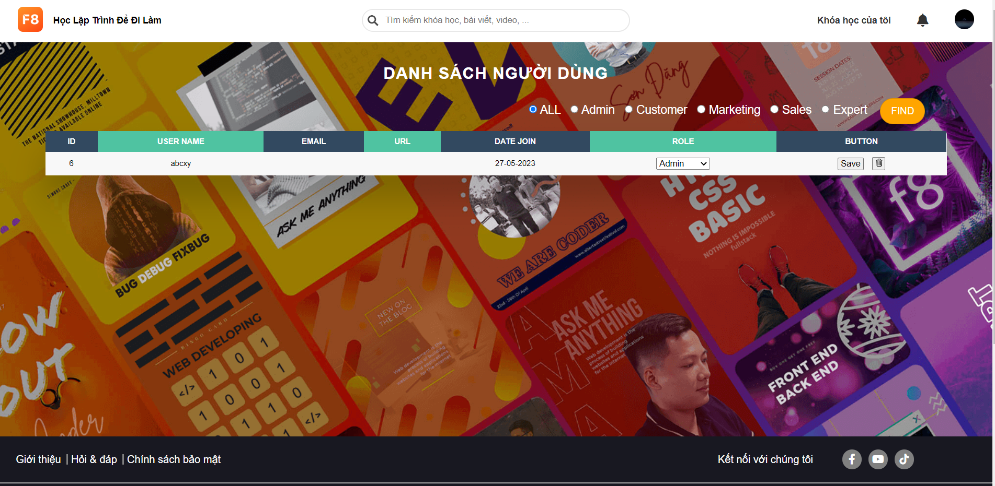

### 

* Function Details: After clicking "Danh sách người dùng", the function will get a list of users from the database and display information such as username, full name, email, role, ...

### b. <<New Course Screen>>

* Function trigger:To use the function, we have to log in as an Expert or Admin and then click on the “Tạo khóa học” icon in the sidebar.
* Function description: This functionality is for Expert and Administrators with course creation permission. The purpose is to create a new course.
* Screen layout:

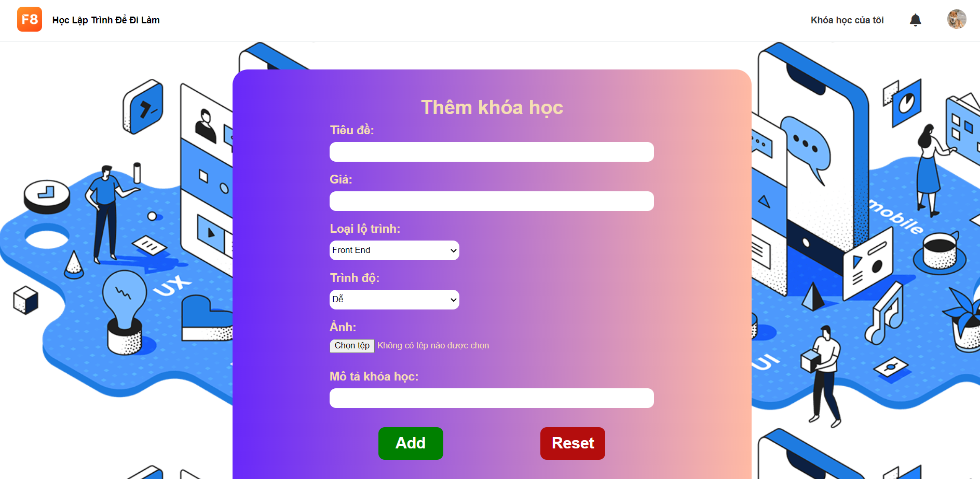

* Function Details: After clicking "Tạo khóa học", the function will allow the administrator or expert to input the information of the new course. After clicking the Add button at the bottom, the function will add a new course to the database and redirect to the Home page.

### d. <<Course List>>

* Function trigger: To use this function, you must log in with the account "admin". After logging in with the account "admin" we click on the avatar then click on the item "Danh sách khóa học"
* Function description:This function is used to allow admin to view the courses that have been created. Here you can switch the admin to the course detail edit screen, or you can delete the created course
* Screen layout:

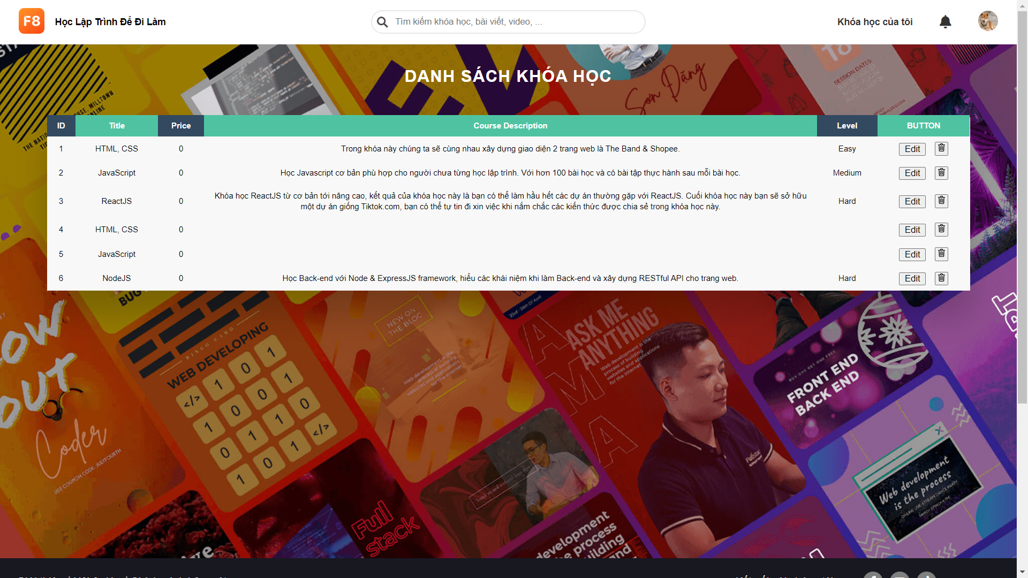

* Function detail: After performing the above steps to enter the page, the page will display information such as blog ID, title, price, course description, level. Here there are 2 buttons for processing, the "edit" button to switch to another screen for editing and the trash can button to delete the created course.

### e. <<General Management screen >>

* Function trigger:To use this function, you need to login to your admin account, then click on settings -> general management
* Function description:This screen has 3 options for you to choose, you can create a course, create a course, and create each item in the course.
* Screen layout:

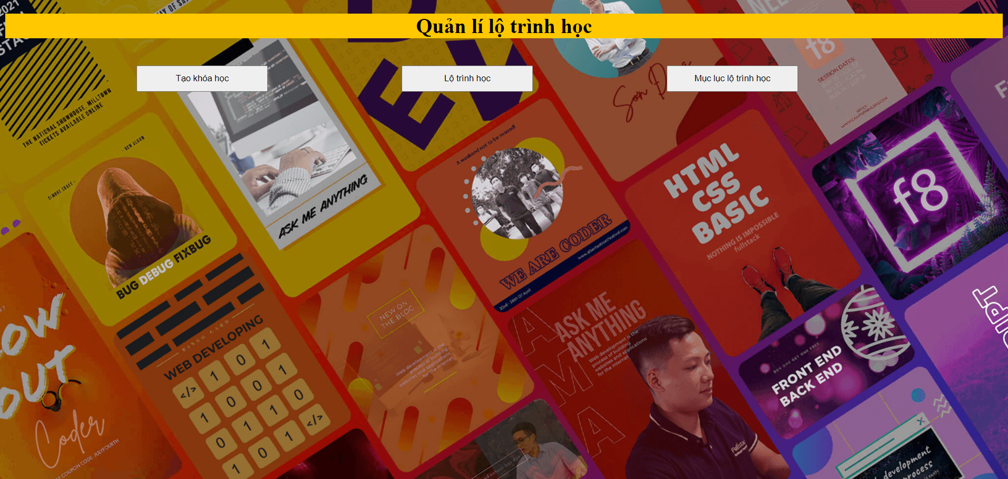

* Function detail: This screen has 3 options for you to choose, you can create a course, create a course, and create each item in the course.

### f. <<New route course screen >>

* Function trigger:To use this function, you need to login to your admin account, then click on settings -> general management → route course
* Function description:This screen will help you to initialize the learning path and after initializing the data will be in the database
* Screen layout:

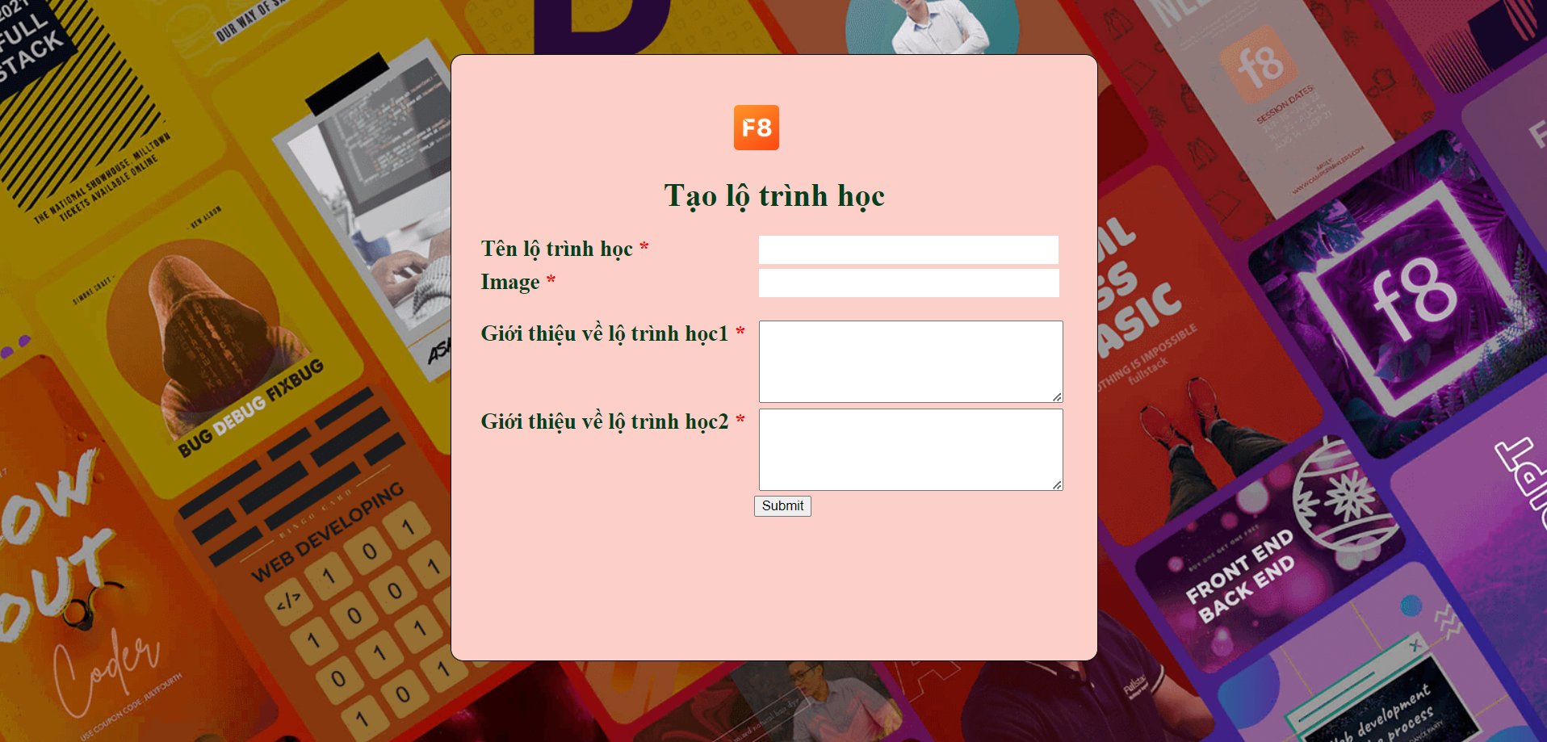

* Function detail: This screen will include initializing route name, image, learning route 1 and learning route 2

### g. <<New route course item >>

* Function trigger:To use this function, you need to login to your admin account, then click on settings -> general management → route course item
* Function description:This screen will help you to initialize the route course item and after initializing the data will be in the database
* Screen layout:

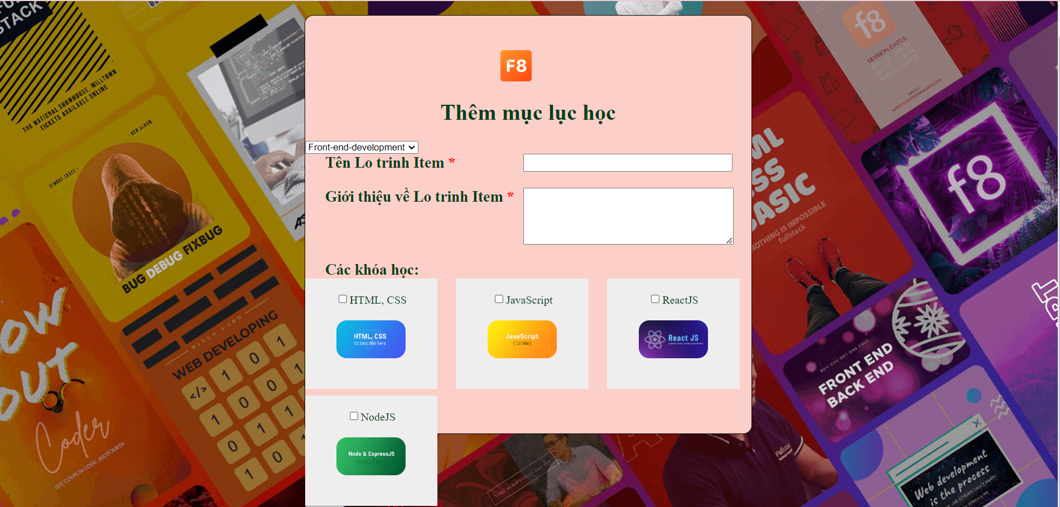

* Function detail: This screen will include initializing the route name item , detailing each item of the route and selecting the route , selecting the course of each route item

### h. <<Comment Management screen>>

* Function trigger: o use this function, click on the avatar icon in the upper right corner of the screen and then click on "Danh sách bình luận".
* Function description: This function can only be accessed by administrators, it allows to view the comment list of blogs, hide or show comments with the push of a button, filter comments by hidden or visible status, search by username.
* Screen layout:

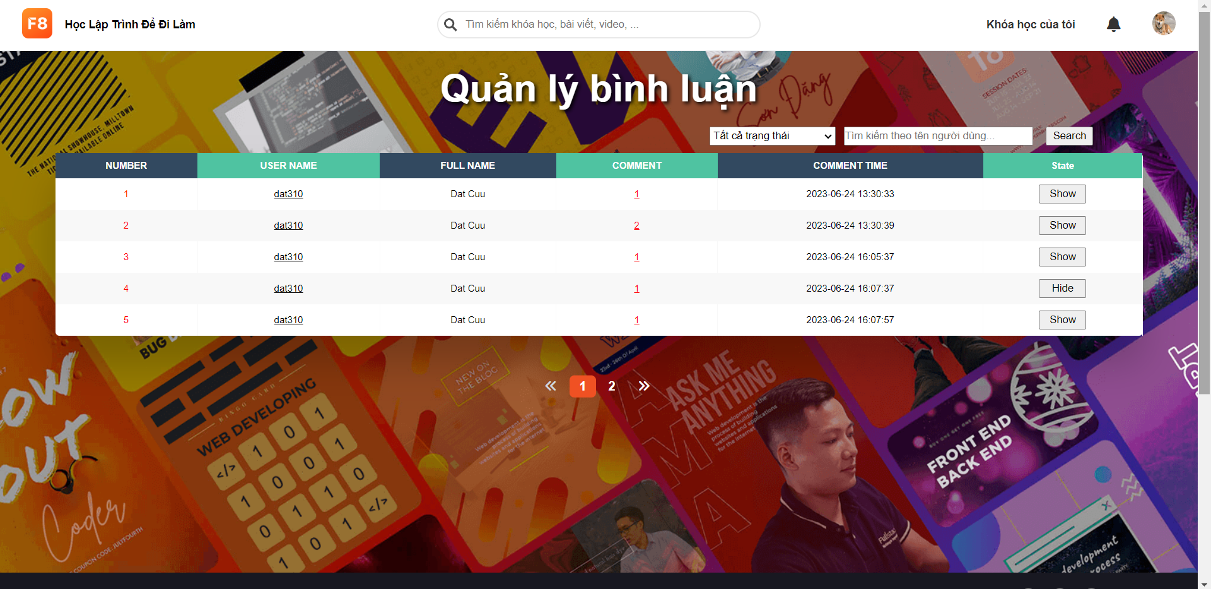

* Function details: Function Details: After clicking "Danh sách bình luận", the function will get a list of comment from the database and display information such as username, full name, content comment, time comment, ...

### i. <<List Quiz Lesson screen>>

* Function trigger: To use this function, click on the avatar icon in the upper right corner of the screen and then click on "Quản lý chung" then click on ‘Câu hỏi’.
* Function description: This function can only be accessed by administrators, it allows administrators to view the list of quizzes, filter quizzes by lesson and delete quizzes.
* Screen layout:

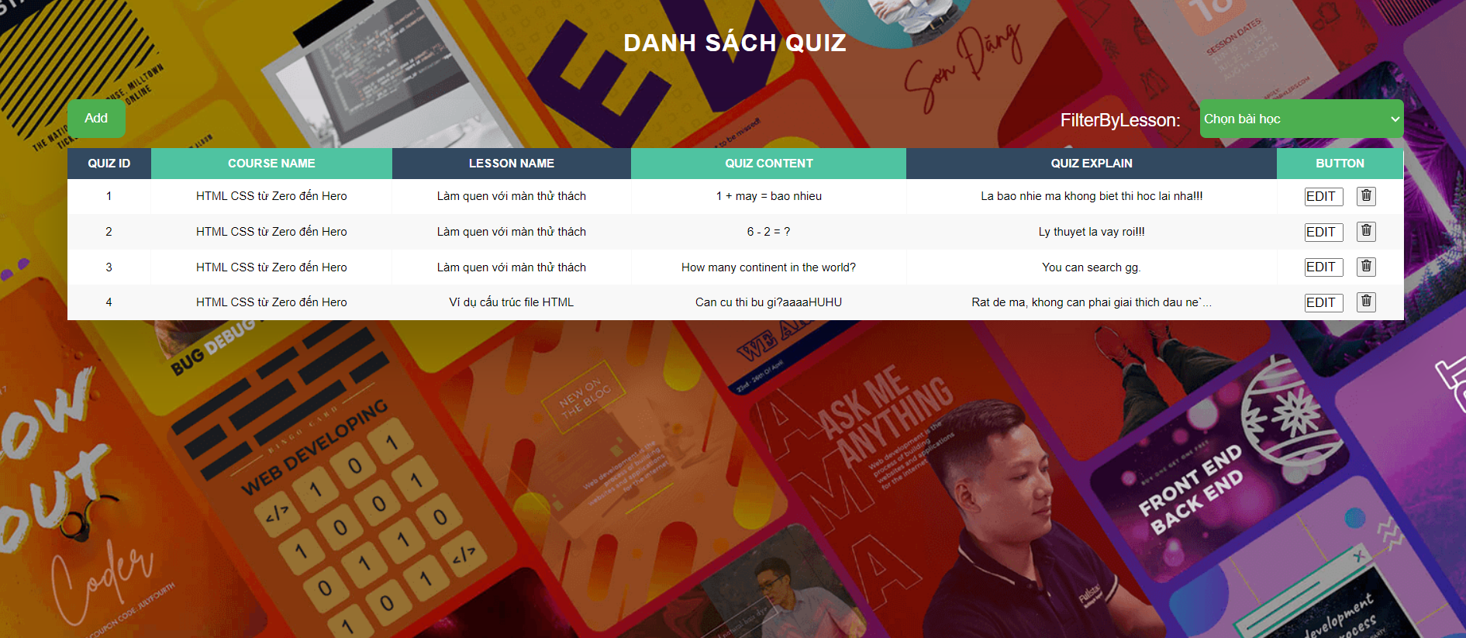

* Function details: After clicking "Câu hỏi", the function will get a list of quizzes from the database and display information such as quizID, course name, lesson name, quiz’s content, quizzes explain, ...

### j. <<Add Quiz Lesson screen>>

* Function trigger: To use this function, click on the avatar icon in the upper right corner of the screen and then click on "Quản lý chung" then click on ‘Câu hỏi’ then click ’Add’ button.
* Function description: This function can only be accessed by administrators, it allows administrators to add the quiz.
* Screen layout:

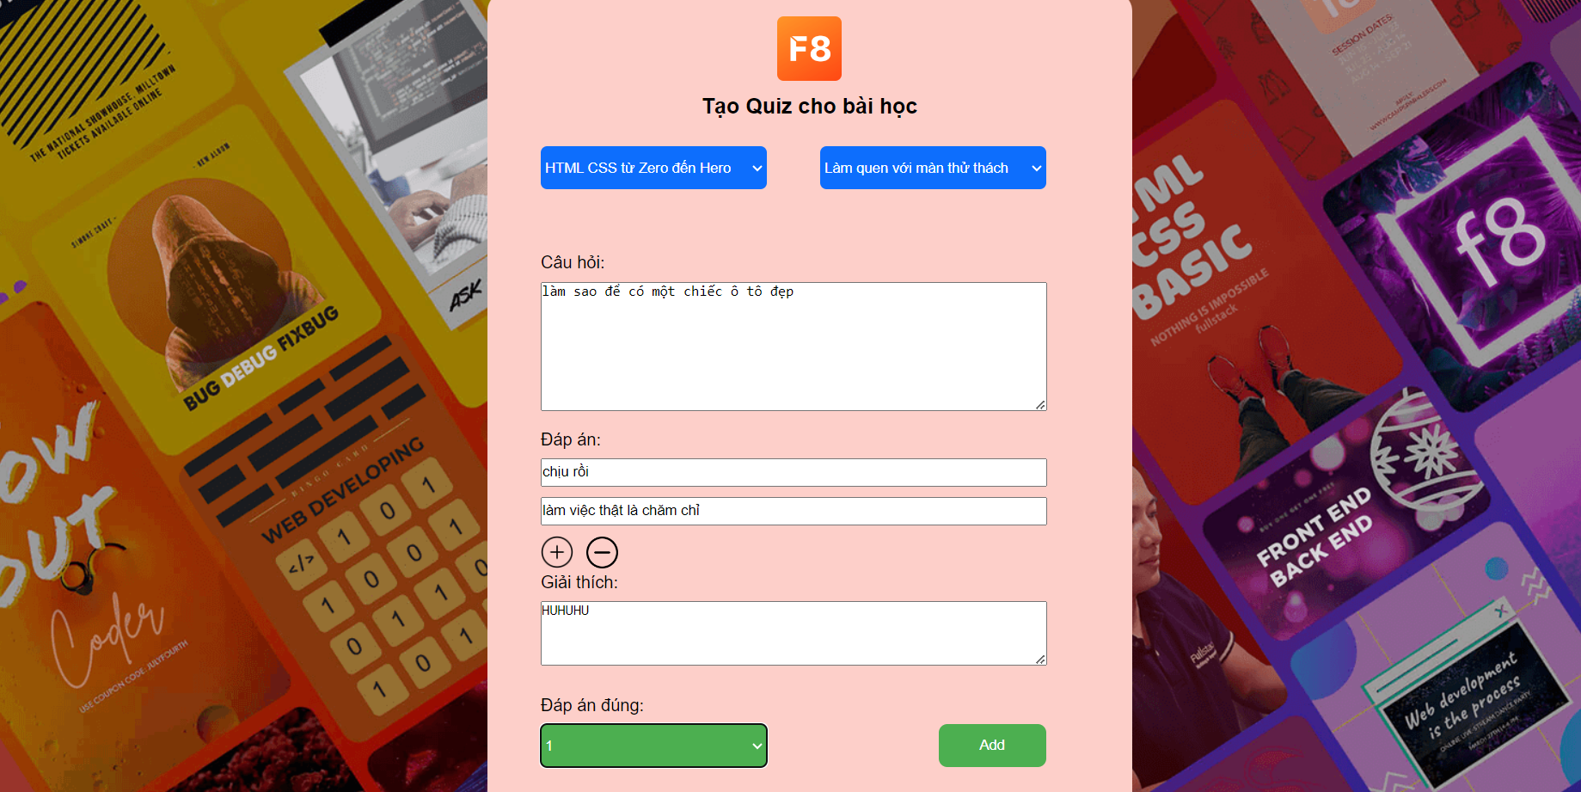

* Function details: After clicking "Add", the function will allow the administrator to select the course, select the lesson and enter the question, answer, explanation and correct answer then submit to create a new Quiz.

### k. <<Edit Quiz Lesson screen>>

* Function trigger: To use this function, click on the avatar icon in the upper right corner of the screen and then click on "Quản lý chung" then click on ‘Câu hỏi’ then click ’Edit’ button.
* Function description: This function can only be accessed by administrators, it allows administrators to edit the quiz.
* Screen layout:

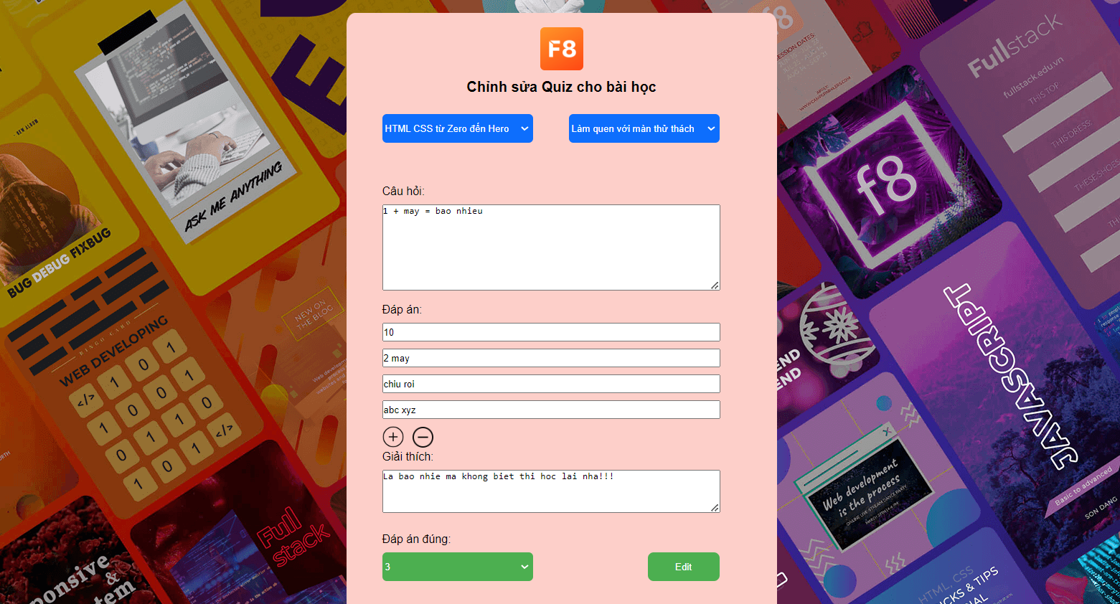

* Function details: After clicking "Edit", the function will allow the administrator to edit all information about the quiz which they have chosen.

### l. <<Course Edit Screen>>

* Function trigger: To use the function, we log in with the Admin account. then press "Quản Lý Chung" press "Khóa học". Here we press the edit button in each course to edit
* Function description: This function can only be accessed by administrators, it allows administrators to edit the course.
* Screen layout:

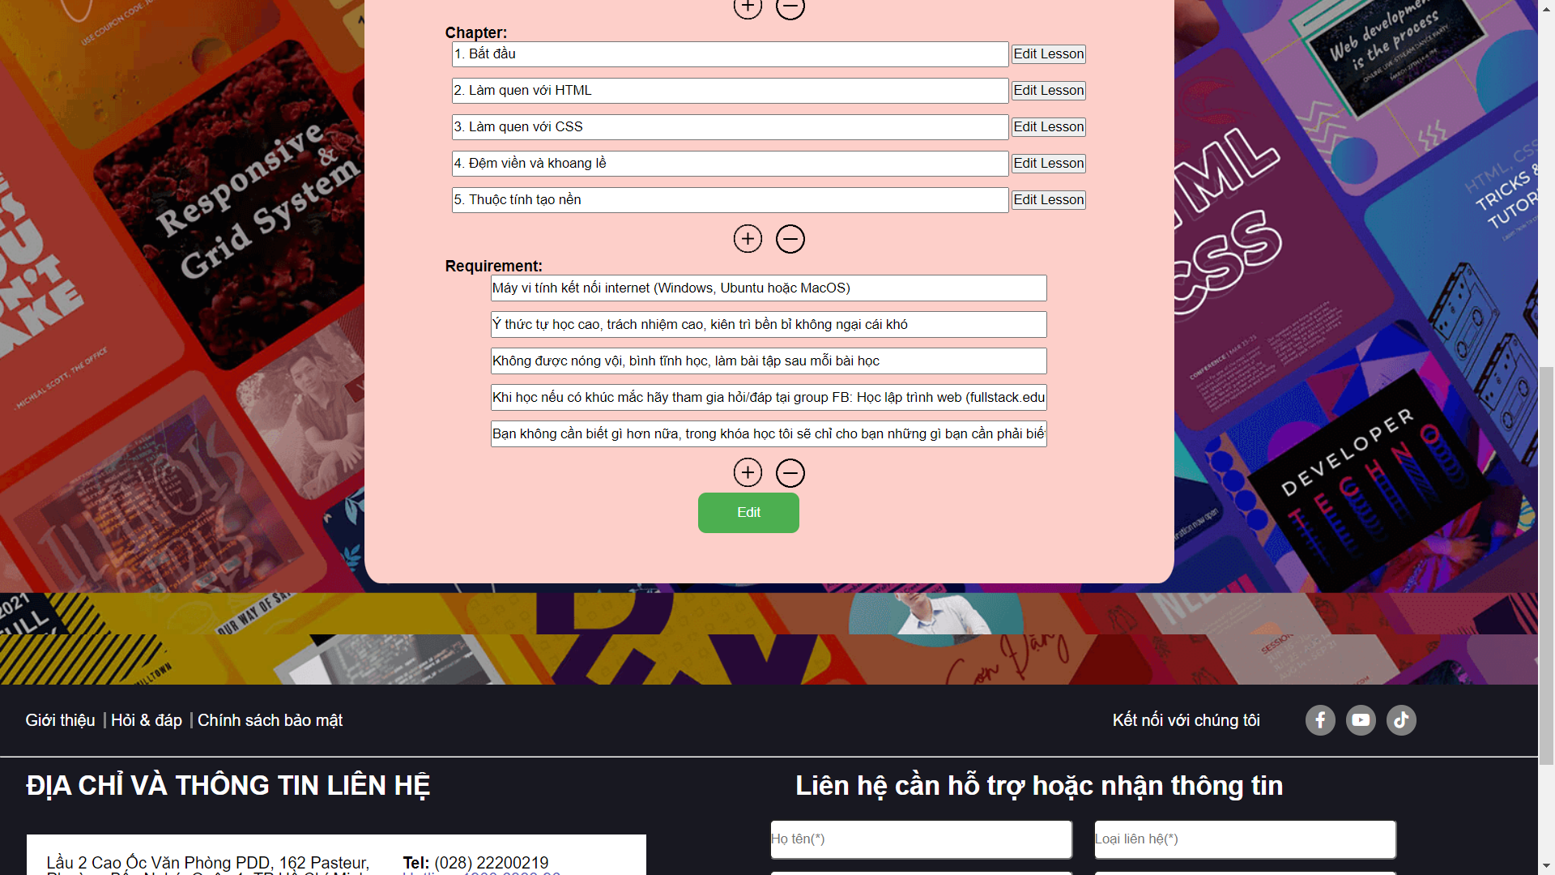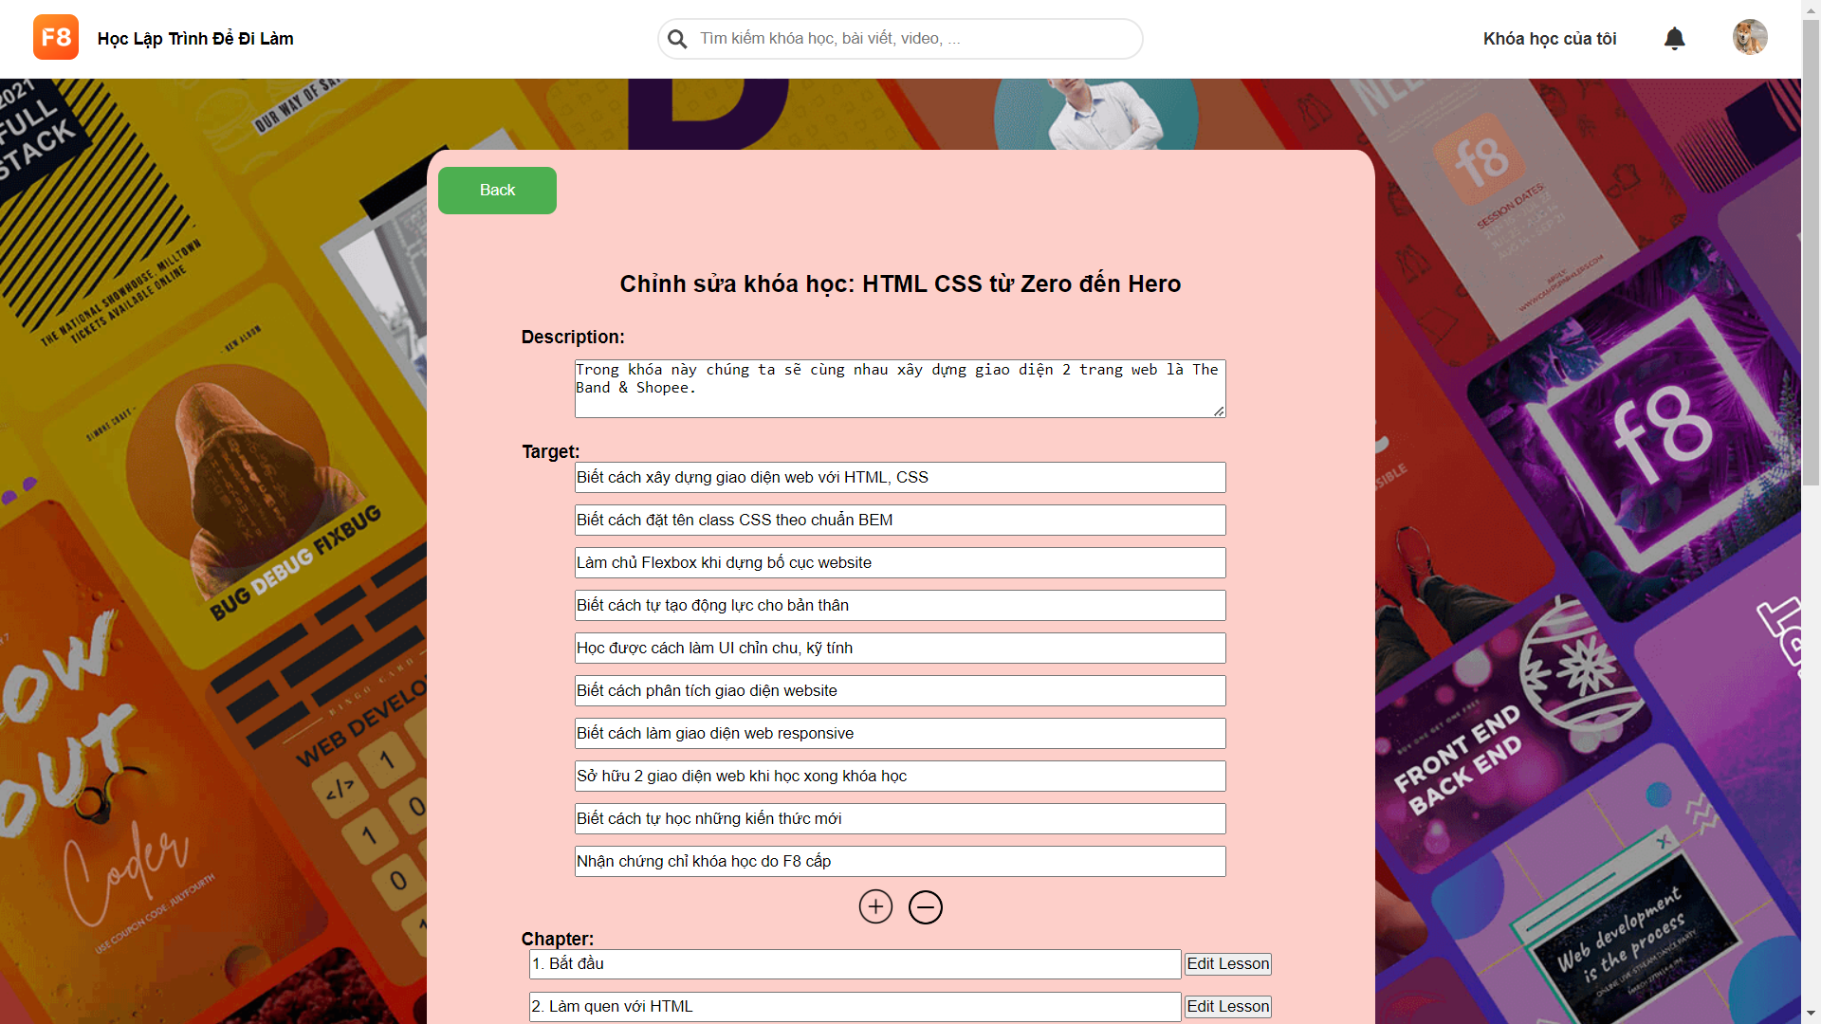

* Function details: After clicking "Edit", the function will allow the administrator to edit description, chapter, target, requirement of the course which they have chosen.

### m. <<Chapter Edit Screen>>

* Function trigger: To use the function, we log in with the Admin account. Then press "Quản Lý Chung" and press "Khóa học". In here we press the edit button in each course to go to Course Edit screen and then press “Edit chapter”
* Function description: This function can only be accessed by administrators, it allows administrators to edit the lesson of chapter.
* Screen layout:

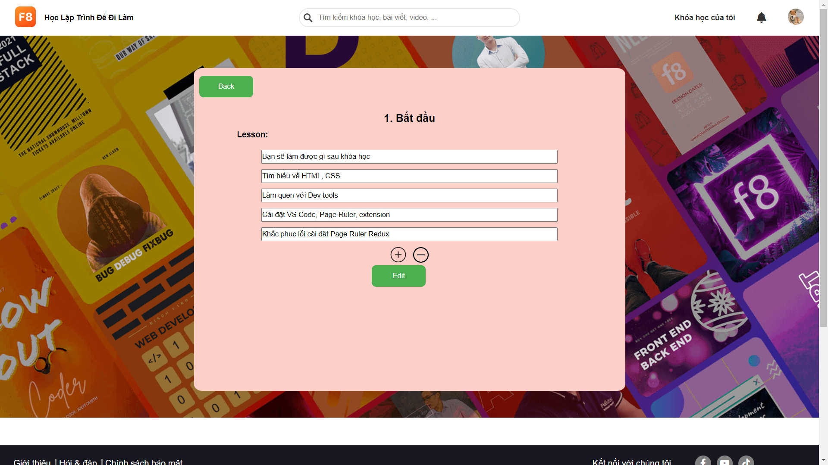

* Function details: After clicking "Edit", the function will allow the administrator to edit the lesson of the chapter which they have chosen.

### n. <<Lesson Edit Screen>>

* Function trigger: To use the function, we log in with the Admin account. Then press "Quản Lý Chung" and press "Khóa học". And then click the title of the course.
* Function description: This function can only be accessed by administrators, it allows administrators to edit the type and add the url of all lessons in course.
* Screen layout:

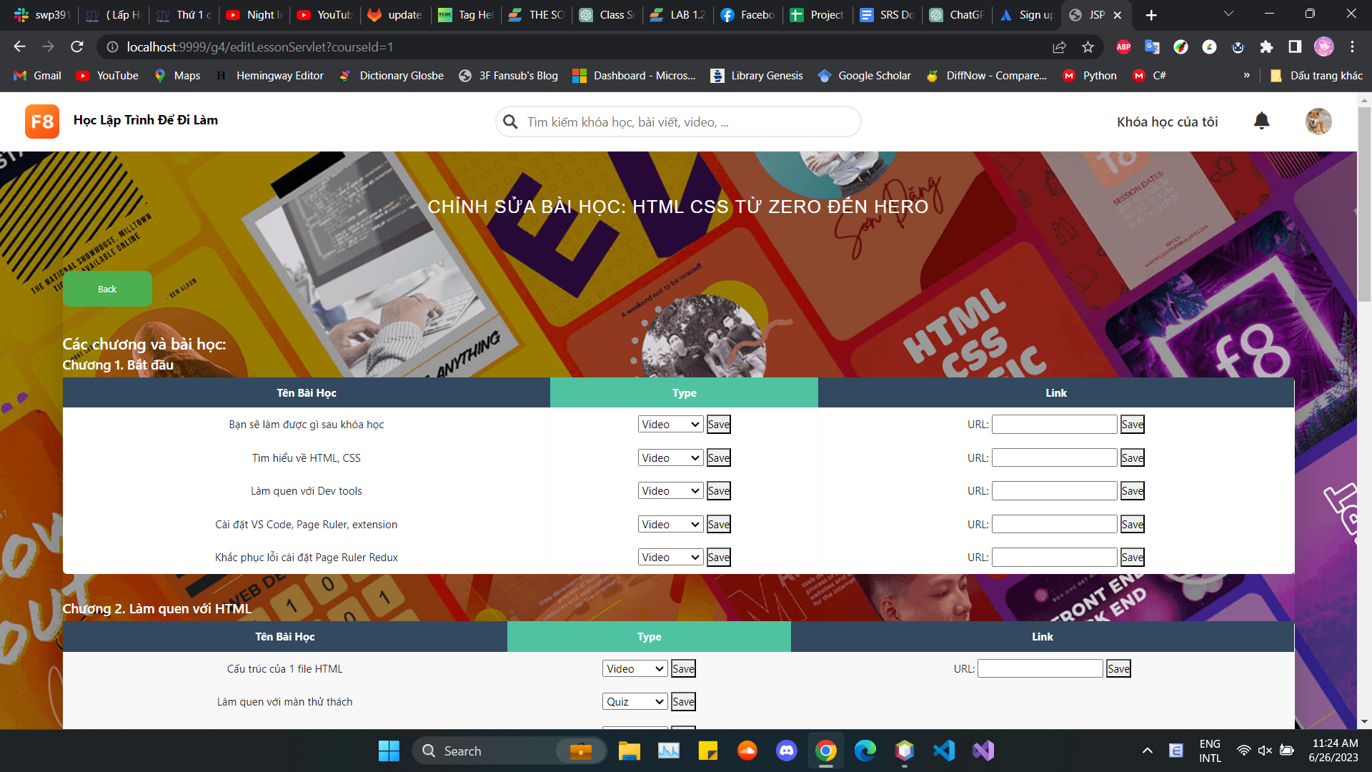

* Function details: After clicking "Save", the function will allow the administrator to edit type the lesson or add the url of lesson which they have chosen

### o. <<Edit Route Course Screen>>

* Function trigger: To use this function, the user must log in to the admin account and then click on “Quản lý chung" and click on "lộ trình học"
* Function description: This function can only be accessed by administrators, it allows administrators to edit the type and add the url of all lessons in course.
* Screen layout:

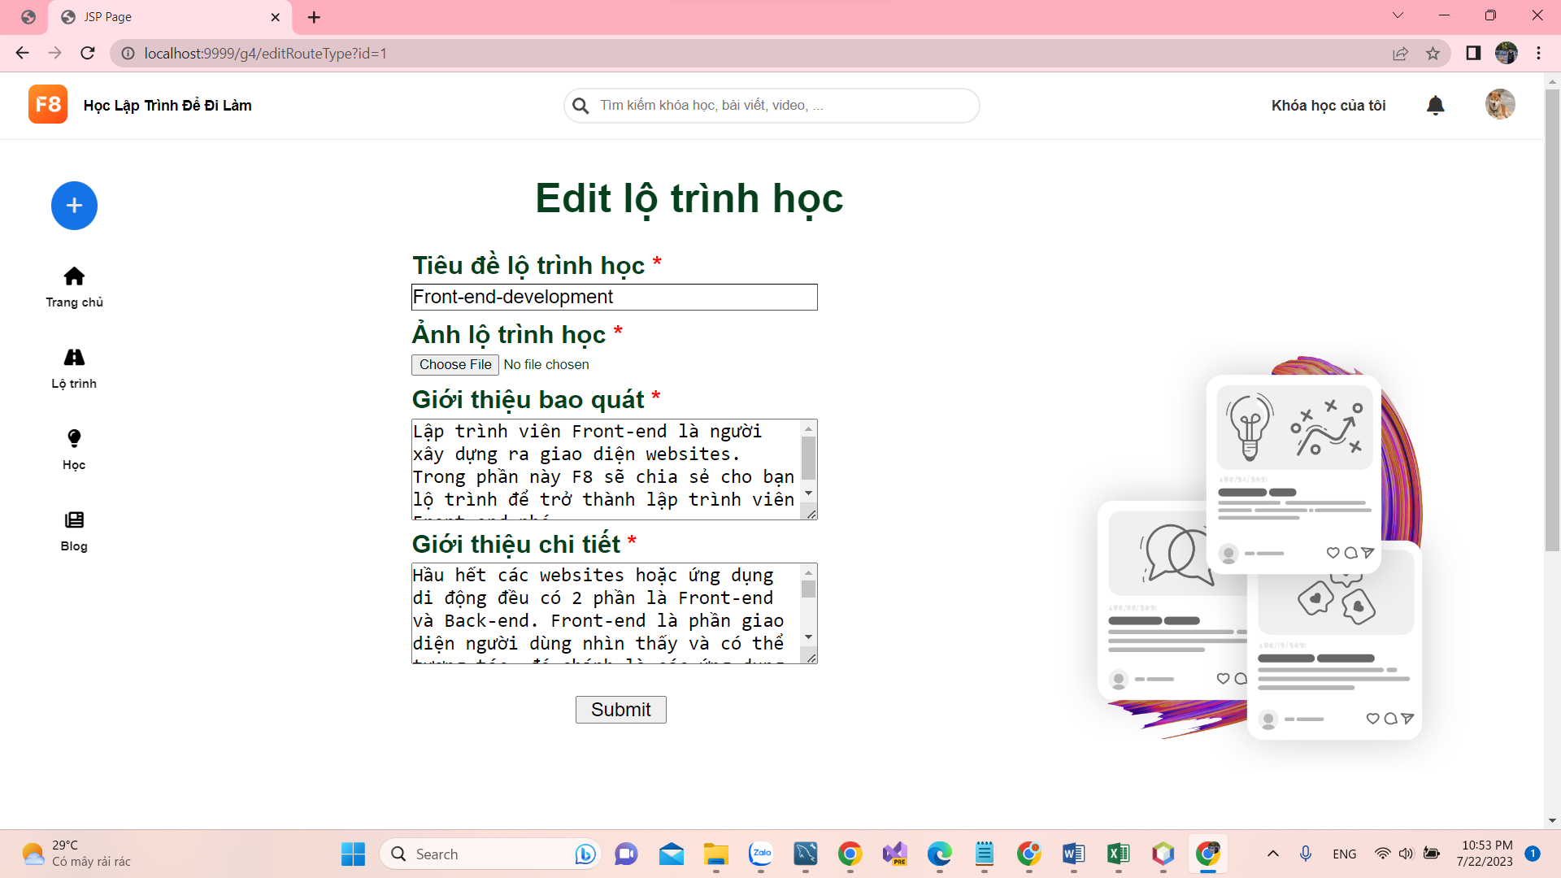

* Function details: This screen will help admin can add, delete and edit a route that I want

### p. <<New route course item Screen>>

* Function trigger: To use this function, the user must log in to the admin account and then click on “Quản lý chung" and click on "lộ trình học"
* Function description: This screen helps admin to create a new table of contents in the learning path that I want
* Screen layout:

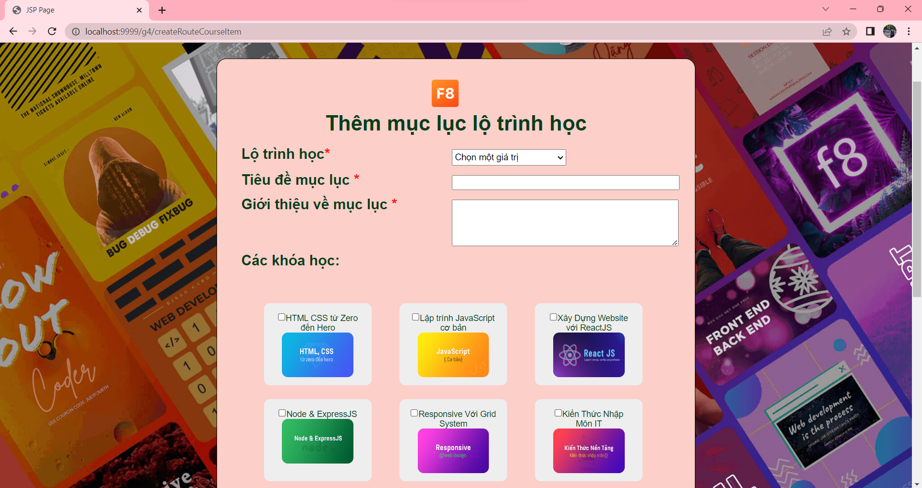

* Function details: This screen has the learning route, the name of the table of contents and the introduction of the table of contents and the course in the table of contents

### q. <<Program list Screen>>

* Function trigger: To access this screen, users will log in with an admin account, then click on "Quản lý chung" and then on "Mục lục lộ trình học"
* Function description:This screen lists all the table of contents for each of those routes
* Screen layout:

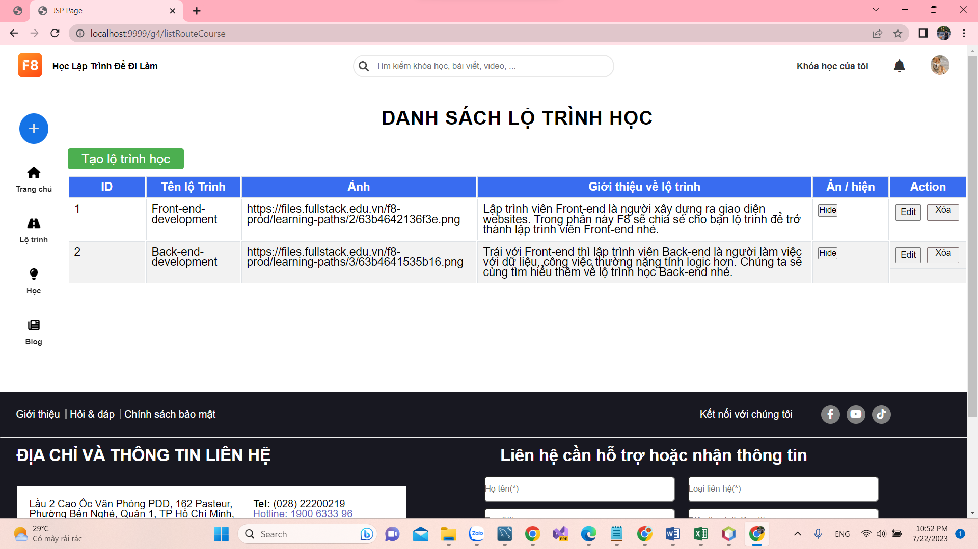

* Function details: This screen helps the admin to add, edit and delete each table of contents of the route

### r. <<edit program details screen>>

* Function trigger: To enter this screen, the admin will go to the "Quản lý chung " section, then go to the "Mục lục lộ trình học" section and finish the edit icon that you want to edit the route table of contents.
* Function description:This screen can edit each route type item if admin want
* Screen layout:

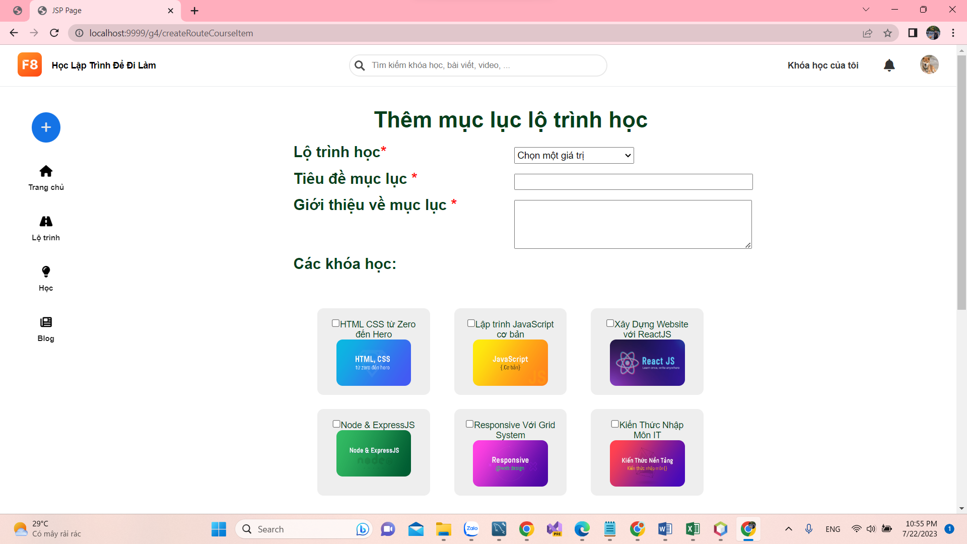

* Function details: This screen helps the admin can edit route type item admin want

### s. <<List Quiz Screen>>

* Function trigger: To enter this screen, the admin will go to the "Quản lý chung " section, then go to the "Câu đố".
* Function description: This screen shows a list of quizzes.
* Screen layout:

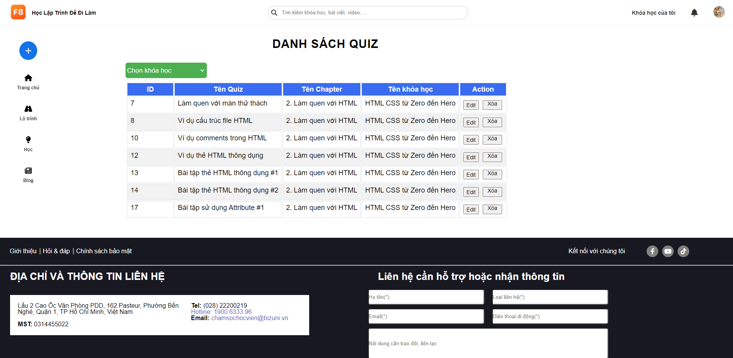

* Function details: This screen helps the admin view a list of quizzes

### t. <<Edit Quiz Screen>>

* Function trigger: To enter this screen, the admin will go to the "Quản lý chung " section, then go to the "Câu đố", then go to edit.
* Function description:This screen can edit quizzes.
* Screen layout:

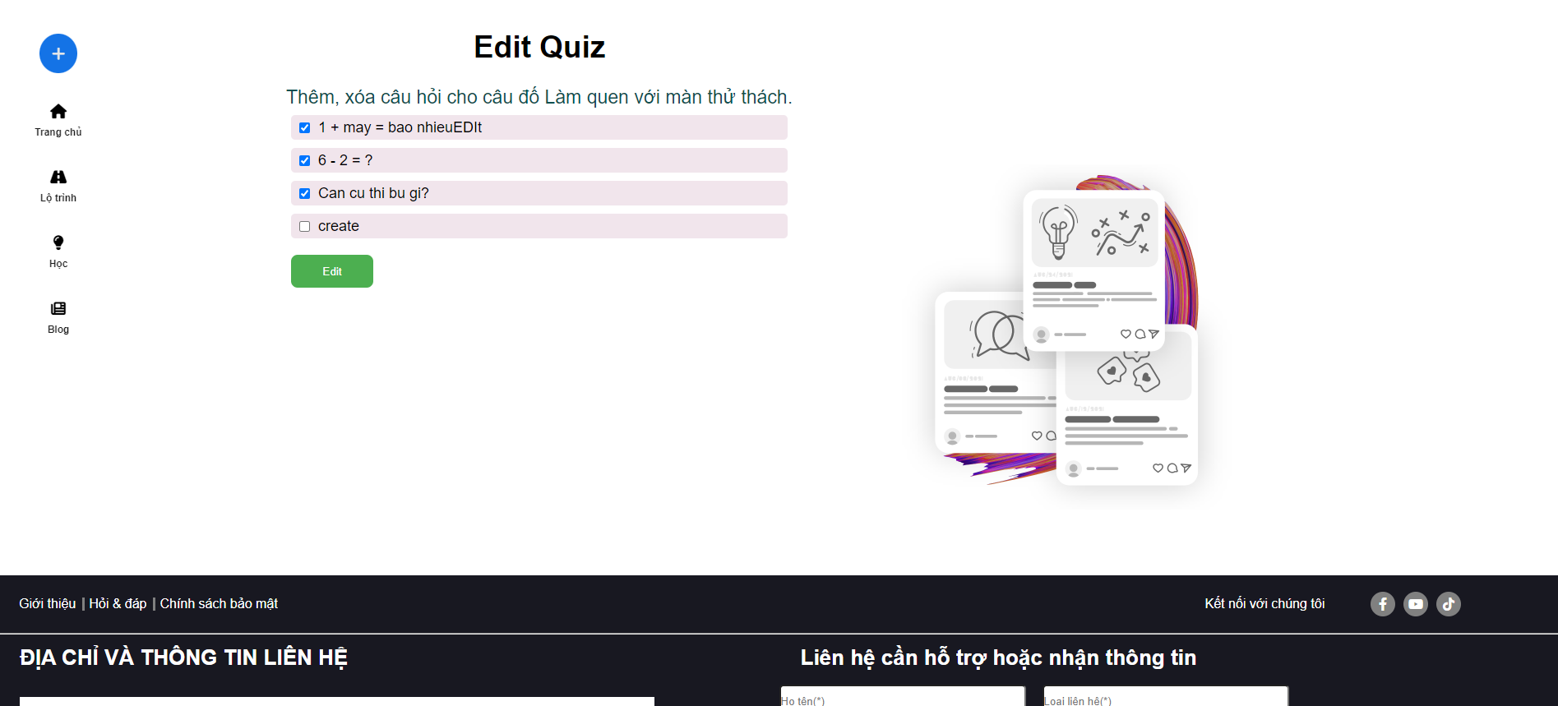

* Function details: This screen helps the admin can edit quizzes.

### u. <<Edit Lesson Detail>>

* Function trigger: To enter this screen, the admin will go to the "Quản lý chung " section, then go to the "Khóa học", click the title of course, have a lesson, then click “edit” in each lesson you want to edit.
* Function description:This screen can edit detailed lessons.
* Screen layout:

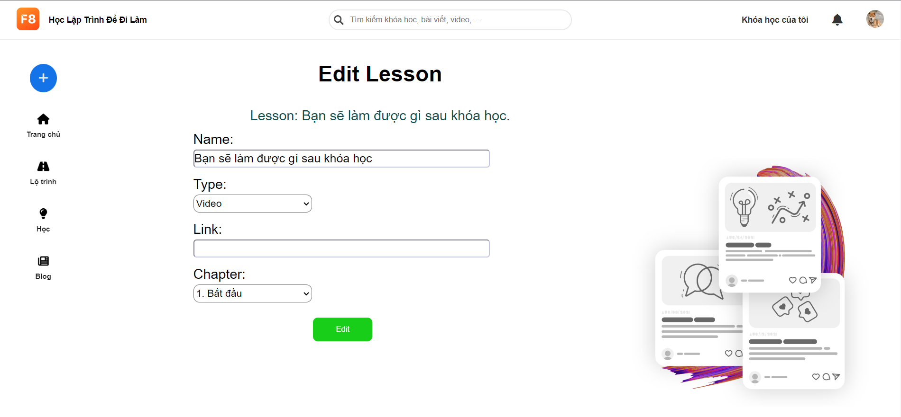

* Function details: This screen helps the admin edit detail lessons.

### v. <<Blog Manager>>

* Function trigger: To enter this screen, the admin will go to the "Danh sách Blog " in avatar
* Function description:This screen can manage blog, hide/show blog in public blog.
* Screen layout:

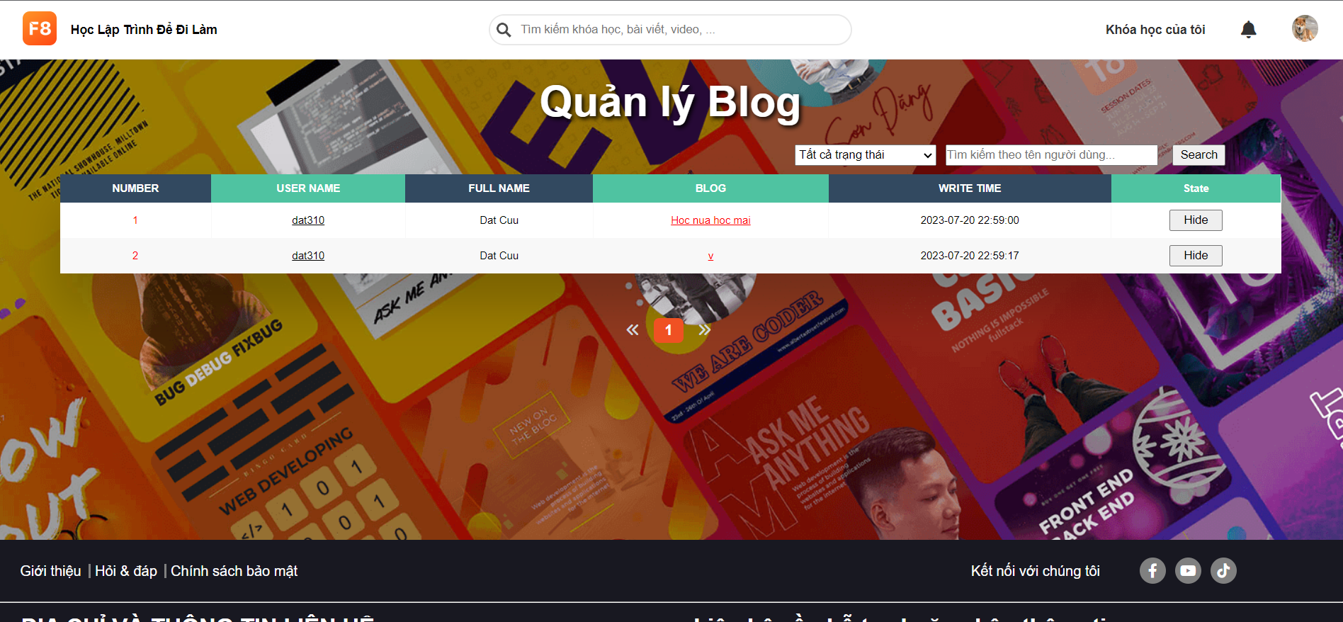

* Function details: This screen helps the admin manage blog.